

Home Learning Pack
Year 1
Week Beginning 25.01.21



Home Learning Links

Oak National Academy
Oak National Academy is an online classroom and resource hub. It provides high-quality video lessons and resources to support teachers, parents and pupils.
www.thenational.academy

BBC Bitesize
With BBC Bitesize it is easy to keep learning at home. You can access regular daily lessons in English, maths and other core subjects.
https://www.bbc.co.uk/bitesize

Phonics English Hubs
Online phonics lessons for the Letters and Sounds phonics programme.
https://www.wandleenglishhub.org.uk/lettersandsounds

World Book Online
World Book online have just made their fabulous collection of over 3,000 e-books and audiobooks available for free for children to access at home. They have books suitable for all ages. Click on the following link to access them.
https://worldbook.kitaboo.com/reader/worldbook/index.html?usertoken=Mjk5MzQ6MTpJUjA5MjAxNjoyOmNsaWVudDE2OTc6MTY5NzoyMjE2Mjg4OjE6MTU4NDM4MDExMzA2Mjp1cw%3D%3D

Read Works.org
Read Works offers access to 3000+ comprehension for all age groups. Just sign up for a free account to access fantastic texts.
https://www.readworks.org/

Beanstalk
Beanstalk website is packed with lots of interactive materials for children aged 1 to 6. They are offering free access to all families during the COVID-19 pandemic.
https://beanstalk.co/

Tutortastic
An online platform with tutorials and videos for home learning.
https://www.tutortastic.co.uk/blog/homelearning

Education Quizzes
A series of short quizzes for children to complete related to the National Curriculum subjects. Just select KS1 for Reception, Year 1 & Year 2 and select KS2 for Years 3-6.
https://www.educationquizzes.com/ks1/

Top Marks
A range of activities here but especially good interactive activities for maths.
https://www.topmarks.co.uk/

Classroom Secrets
Classroom Secrets Kids is offering free access to everyone until the end of April 2020. The platform is aimed at primary aged children and covers subjects such as maths, reading, grammar and spelling. The platform is really child-friendly so that they're able to access it on their own. There are a load of games and interactive activities from phonics to SATs
https://kids.classroomsecrets.co.uk/

National Geographic
National Geographic is a great platform for learning and it’s totally free. There are online games, resources and competitions, too.
https://www.natgeokids.com/uk/teacher-category/primary-resources/

Reading Eggs

NOTICES FOR PARENTS
This week we will be following instructions to make a sandwich for their lunch (any filling you want) and porridge with toppings of your choice. (If they do not like porridge then any breakfast cereal is welcome).

Key Question Week 4: Would you venture into the Bear’s house?
Key Text for Linked Learning: Goldilocks and the Three Bears
Linked Learning: English, Science, D&T, PDW, Computing and History
This week, the children will be continuing their learning of the story ‘Goldilocks and the Three Bears’. Using their knowledge of making porridge, the children will be writing their own set of instructions to make porridge. To support their writing, the children will be identifying the different features of instruction writing such as time adverbs and imperative verbs and highlighting these features in instructions. In addition to this, children will be following a set of instructions to make a jam sandwich for baby bear. CAUTION – no teacher’s help will be provided! Children will then be using their voices to create sound effects for different parts of the story. In Computing, children will create their own Goldilocks story and will save and retrieve their work. The children will be discussing the different behaviours that Goldilocks presents and what strategies would help. The children will also be applying these strategies in everyday situations and thinking about the other person’s point of view. In Science, children will also will be thinking about animals found in the forest where the Three Bears live. They will identify, compare, describe and sort common mammals and birds. Continuing on from last week, children will demonstrate knowledge of healthy and unhealthy options when selecting toppings for Goldilocks’ porridge. In addition, children will sequence events chronologically for a member of their families’ life.
Maths: Children will estimate, measure and compare objects, choosing and using suitable uniform non-standard or standard units; Use vocabulary related to time; Read the time to the hour (o’clock) and half past the hour.
Science: See above
History / Geography: See above
Computing: See above
Music: Children will listen with concentration to different musical pieces and will begin to comment on pitch, tone, tempo, rhythm and dynamics.
Art / Design Technology: See above
PDW / R.E: See above
P.E: The children will be practising the main throwing techniques taught so far; over, under and bounce passing. This will be practised by a range of invasion games; bench ball and dodgeball.

Zoom Timetable
Monday | AM  English, Science and Phonics | PM  Maths, Computing and Reading
Tuesday | AM  English, Science and Phonics | PM  Maths, PDW and History
Wednesday | AM  English, DT and Phonics | PM  Maths, PE and Science
Thursday | AM  English, PDW and Phonics | PM  Maths, Geography and History
Friday | AM  English, Science and Phonics | PM  Retrieval Quiz

Monday AM
English – Instructions
Look at the instructions below, the instructions have been placed in the wrong order but can you sort them back into the correct order by numbering them 1 to 5 or cutting them up and ordering them.
Once completed, can you highlight the verbs and adverbs in these instructions?
REMEMBER: Verb is a word that speaks about an action (put, cut, spread etc). Adverb is a word that changes a verb, an adjective, and another adverb (for instructions it changes by telling you when to do something 1st, 2nd 3rd etc)

Third, spread jam on nice and thick.
Second, spread butter on bread with a knife.
Finally, cut it in to two bits ready to eat.
Next, put the other slice on the top.
First, get jam and bread and butter.

Science AM
Labelling – What type of bird is this? Can you label this bird? You can either cut and stick the labels into the correct place or by writing the features of a bird using the word bank at the bottom.
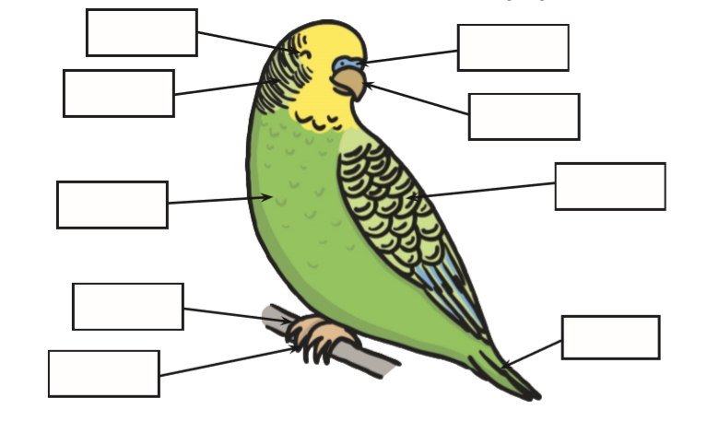

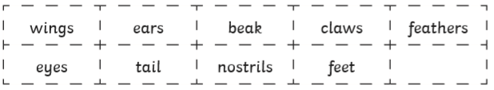

Phonics AM – Can you spot the digraphs by sound buttoning the words below, using robot arms and sorting them into real and non-sense words.
Challenge: Put the real words into sentences.
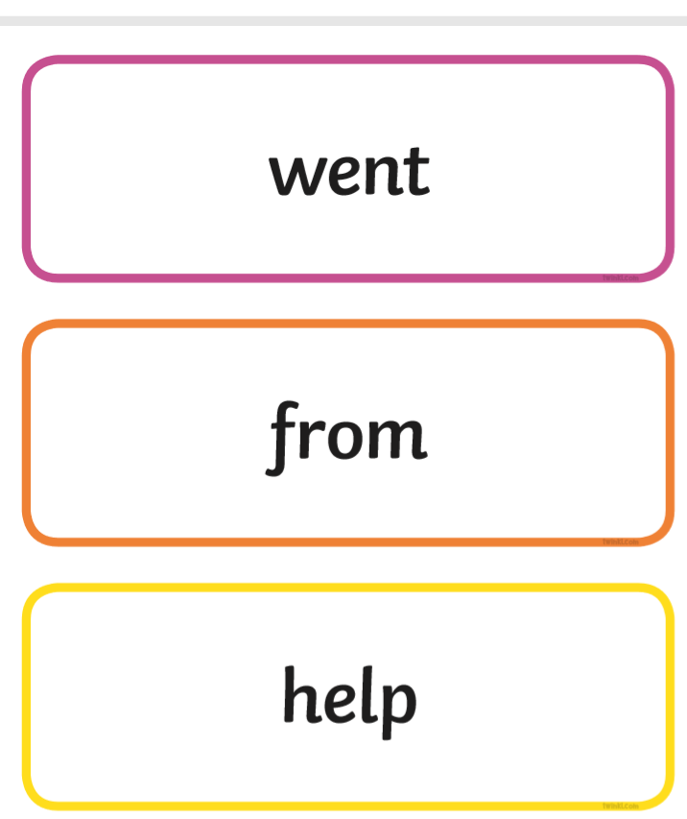
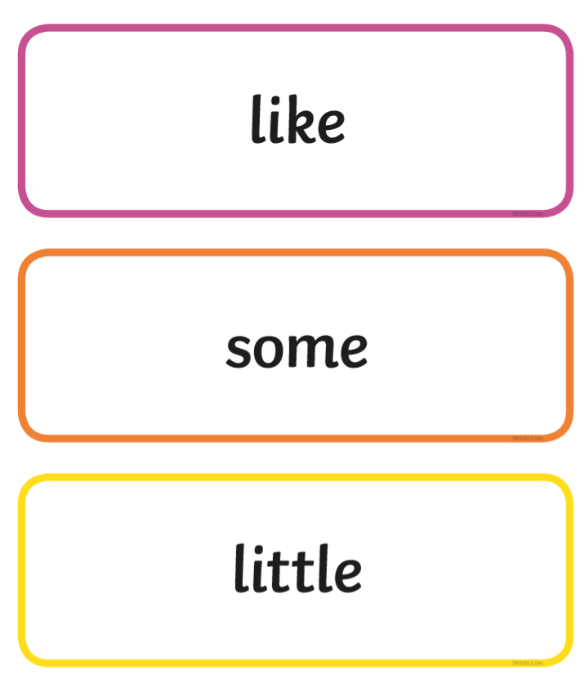
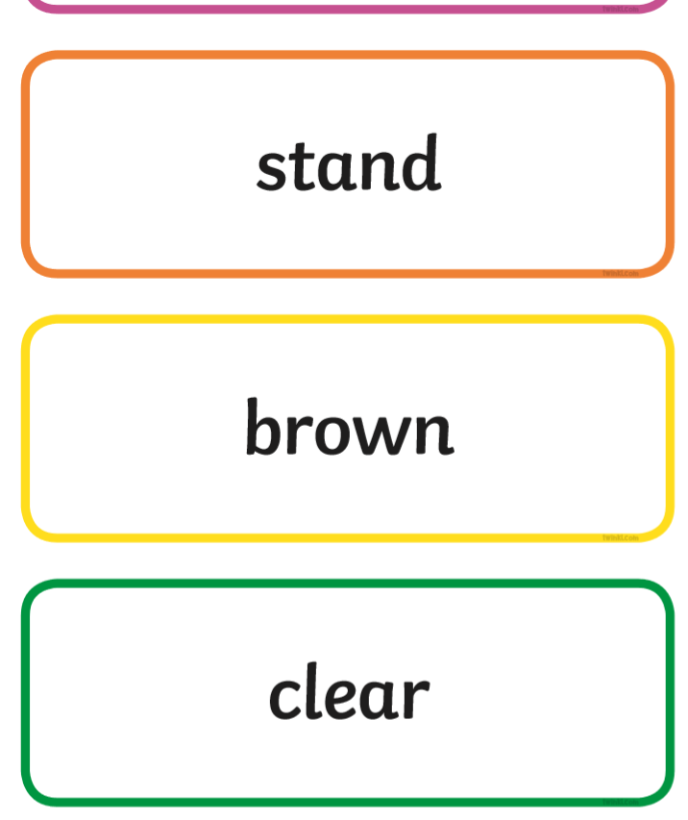
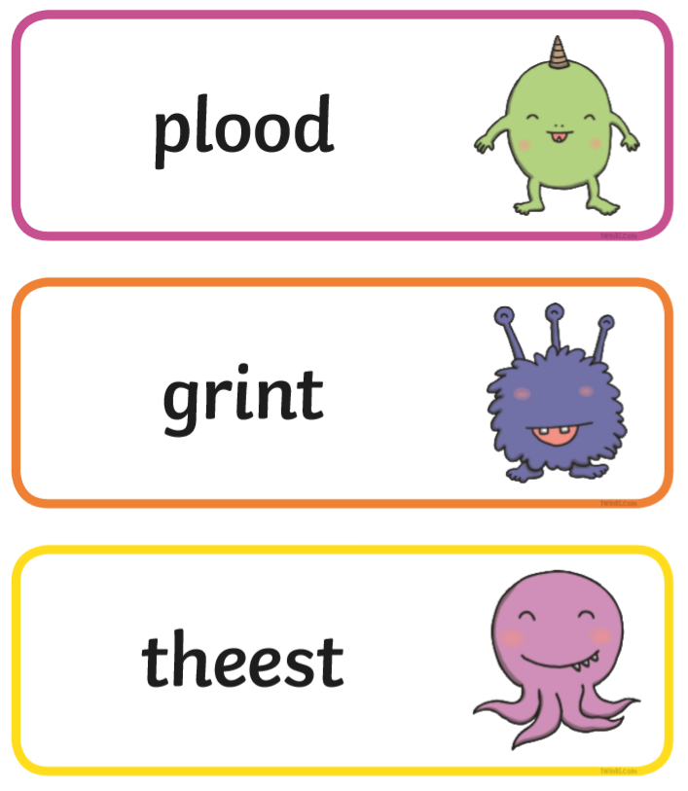
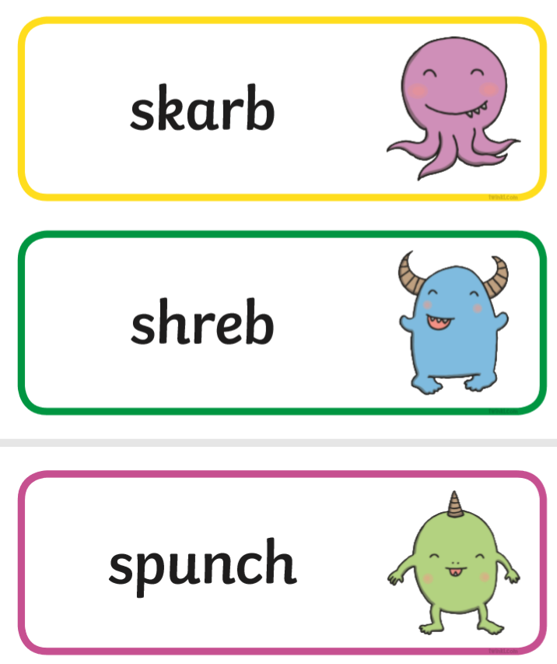
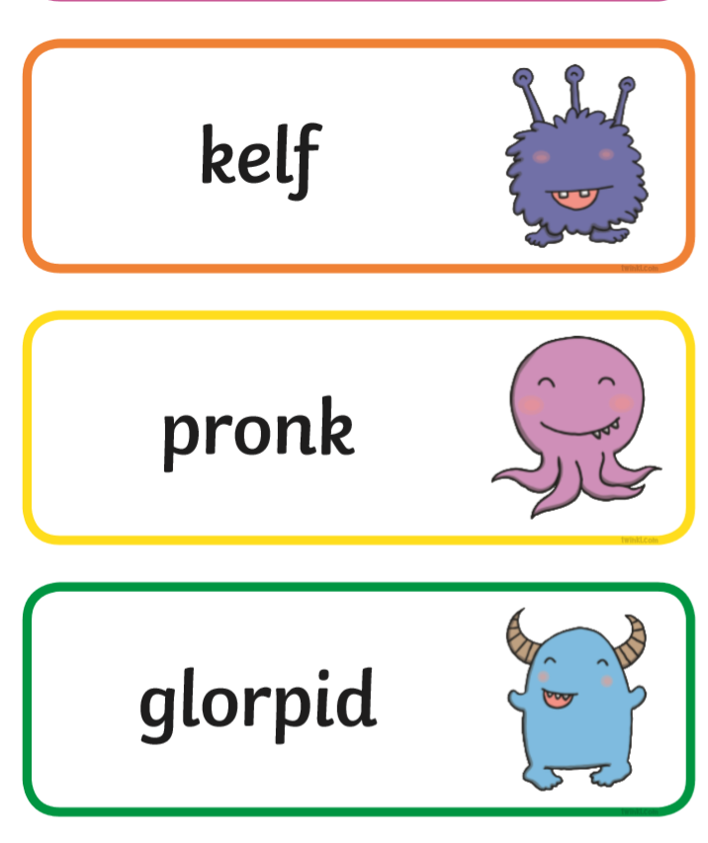

Maths PM – Estimate, measure and compare.
Look at these objects – can you guess how many cm they would be?
Can you then measure them using a ruler? Remember to always put the objects at the end of the ruler 0 or 1cm. (Measure the ones on the sheet)
Lastly, compare them which is the longest or shortest; how do we know?
Challenge: Can you estimate, measure and compare items in your home next?



Estimate  (cm) | Measurement  (cm)

Estimate  (cm) | Measurement  (cm)

Estimate  (cm) | Measurement  (cm)

Computing PM
Design your own animation of Goldilocks and the Three Bears.
Using a tablet, ipad or computer can you remake the story of Goldilocks and the Three Bears; draw pictures, type the story using the keyboard etc.



Reading PM

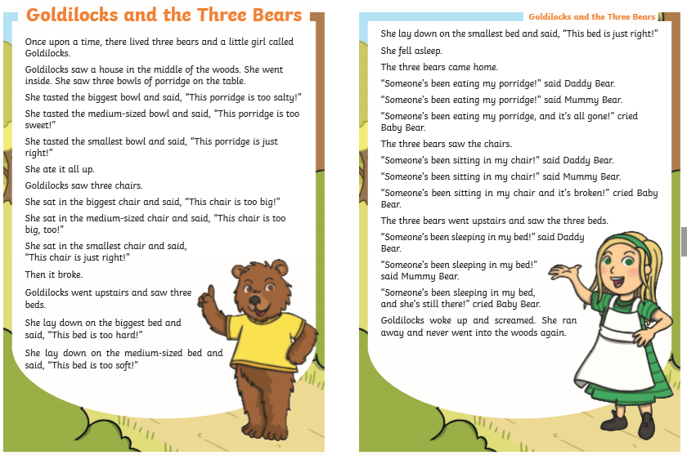

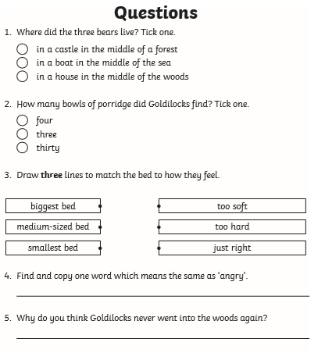
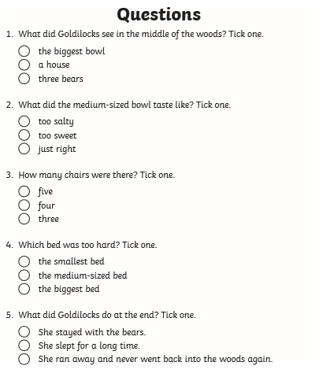

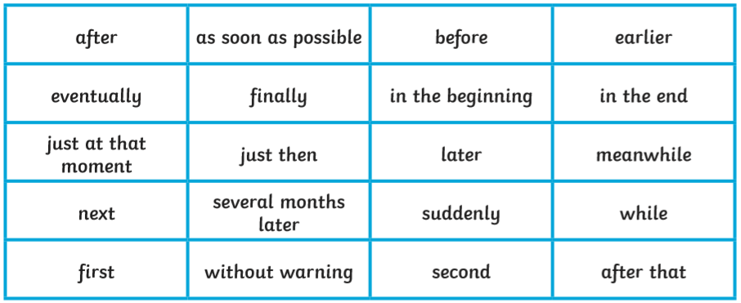
Tuesday AM
English – Can you add in the adverb to these instructions?
First, can you put the instructions in the right order?
Then can you add the adverb (First, Second etc)

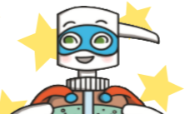
Finally, can you highlight the verb (doing word)

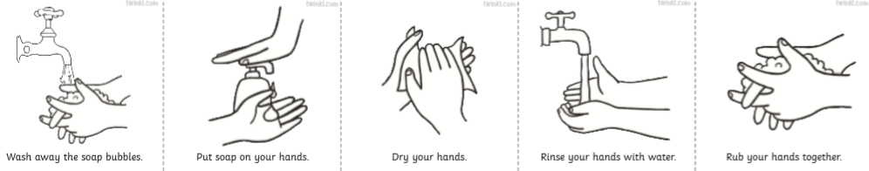

Science AM
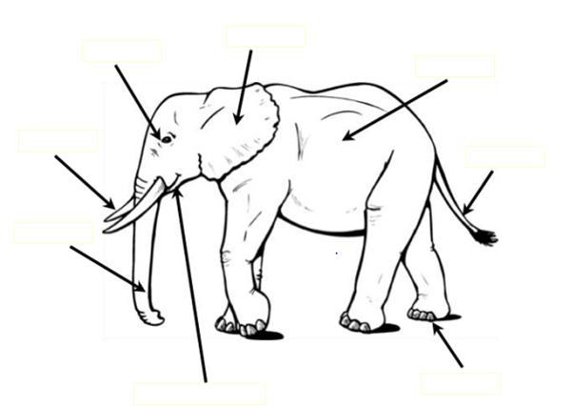
Labelling – can you label this mammal? Use the words mat to help you.

eye
ear
tusks
trunk
skin
tail
foot
Mouth and lips

Phonics AM
ay | ou | ie | ea
oy | ir | ue | aw
wh | ph | Write a word in each box and then put it into a sentence.  Listen to them again – Alphablocks, Geraldine the Giraffe or Little Sutton Phonics online.

Maths PM
Lines | Estimate | Measure (cm)
Pink
Blue
Red
Green
Yellow

Compare:
The pink line is _________________________ to the blue line.
The red line is _________________________ to the green line.
The yellow line is _______________________ to the blue line.
The blue line is _________________________ to the red line.

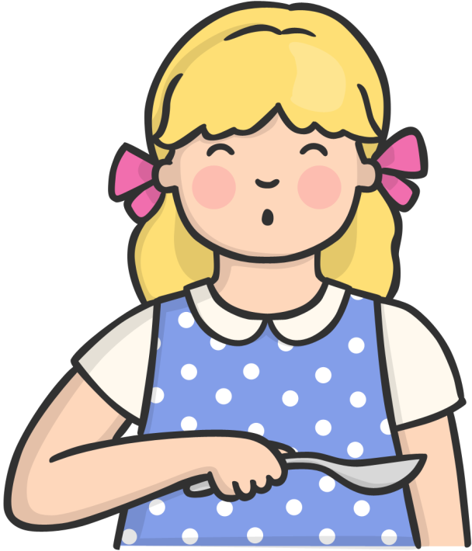
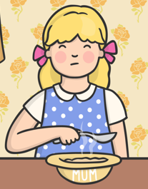
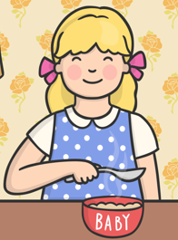
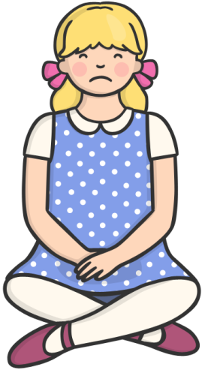
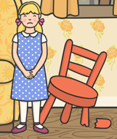
PDW PM

What should she have done? How could she make it better?
__________________________________________________________________________________________________________________________________________________________________________________________________________________________________________________________________
What wrong choices did goldilocks make?
Goldilocks entered a houses she wasn’t invited into.

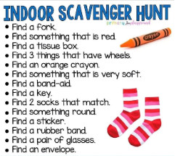

History PM
Ordering events in chronological order and add in the correct vocabulary.

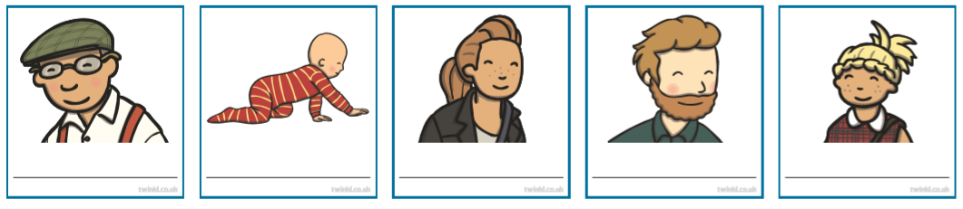
baby | child | teenager | adult | elderly
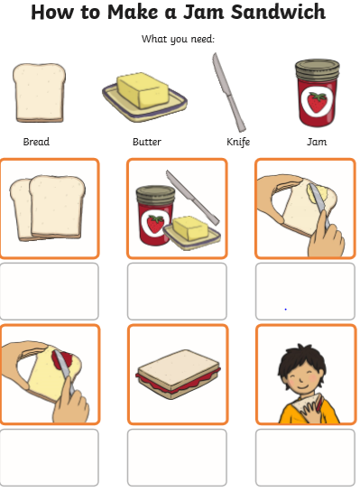
Wednesday AM
English – Match the instructions to the correct picture. Once completed can you add a time adverb to the picture (First, Second, Then etc)
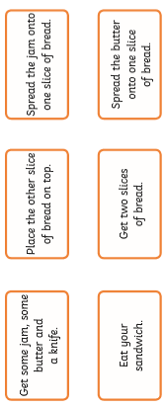

DT AM
Design a healthy sandwich that you can make at home for lunch. (Take photos of each stage)
Remember your healthy and unhealthy list from last week.

Phonics AM
Can you sound button these words as well?

https://www.youtube.com/watch?v=HcyOeWd96w8
‘ew’ digraph = ‘oo’
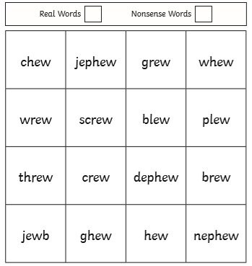

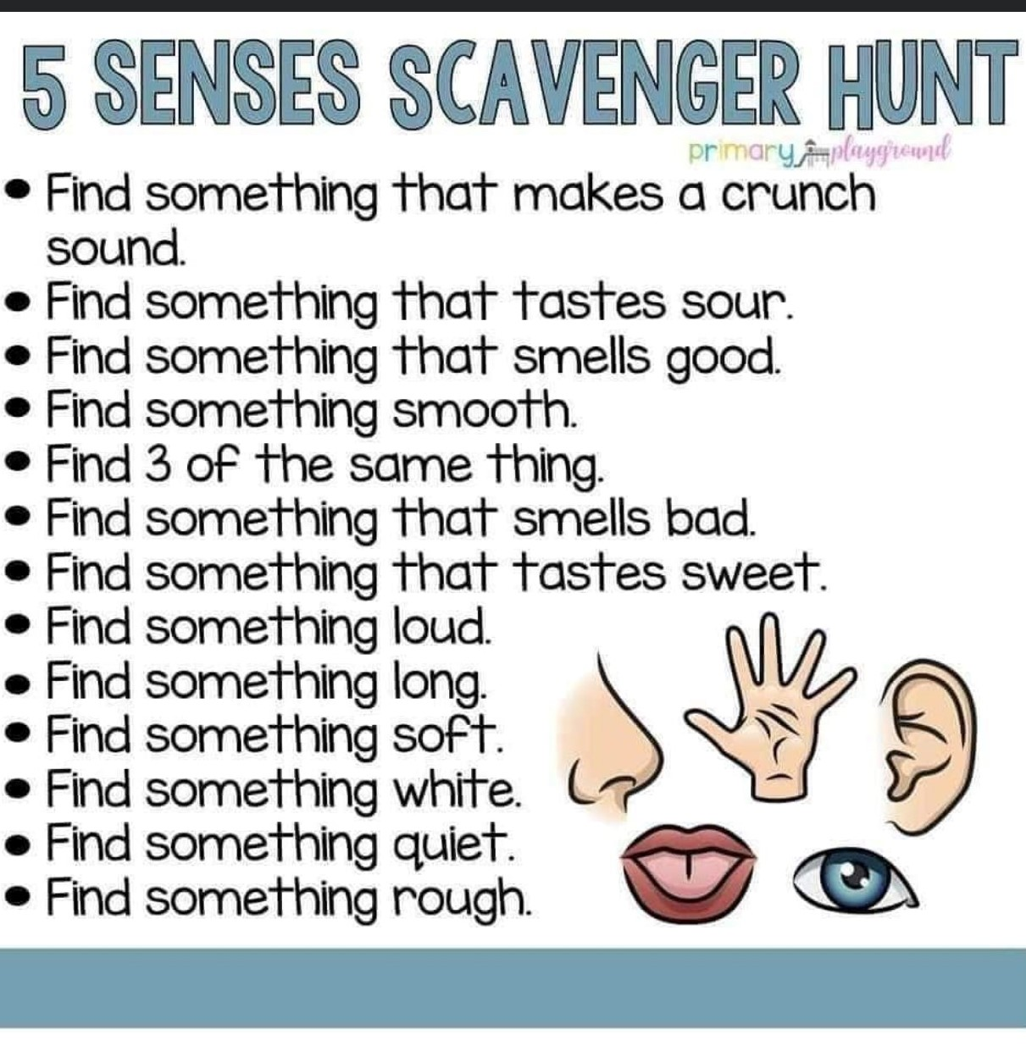
PE DAY – Dance
Science – Senses scavenger hunt

Maths PM
Standard and Non-standard measurement.
Objects | Non-standard measurement | Standard measurement (cm)
Plate | 15 paperclips | 22cm

Thursday AM
English – Instructions writing
Miss Beardmore is going to make porridge on Teams and you are going to write the instruction for it after.
Equipment | 40g porridge oats 200ml of milk  Cooking hob saucepan bowl wooden spoon serving spoon sugar
First
Next
Then
After that
Finally
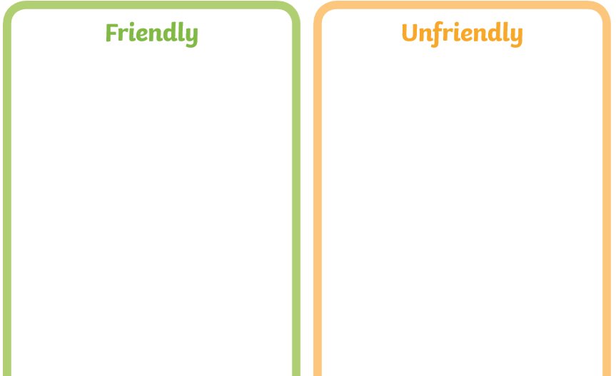
PDW AM

Look at the situations which ones are friendly and which ones aren’t.

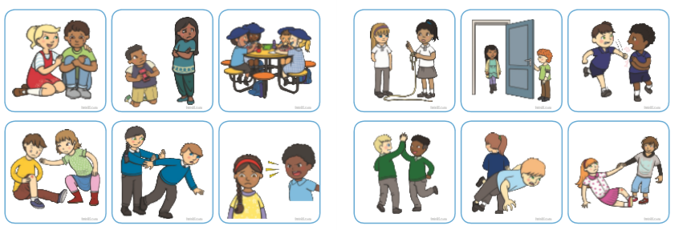
For the unfriendly one, what strategies would you recommend they use to ensure that it doesn’t happen again?

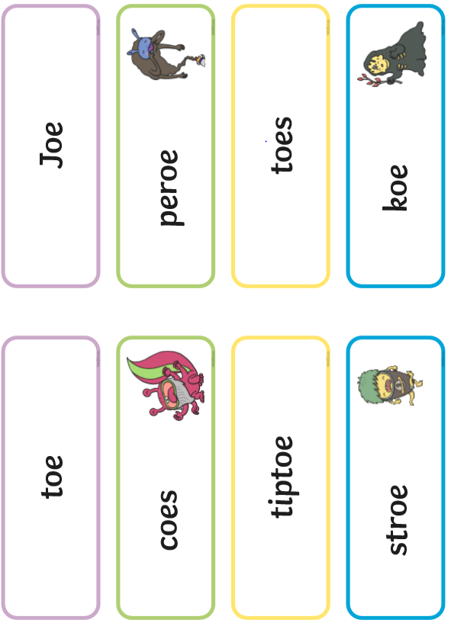
Phonics AM
‘oe’ digraph
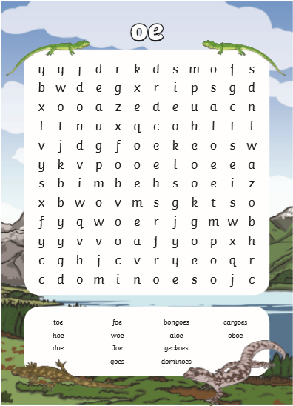
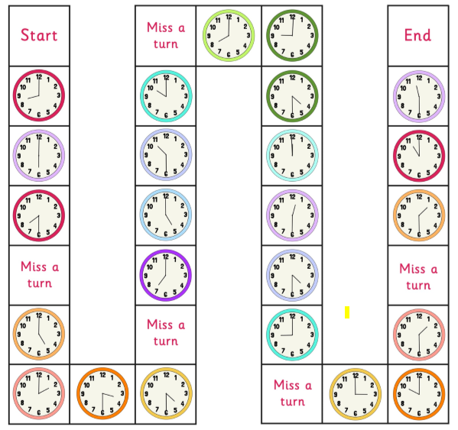
Maths PM
O’clock and Half Past

Geography PM
Create your own map using your knowledge of the three bears.
What features would you have?
Features:
Forest

Cottage

History PM
Chronological Ordering – use photos from a family member; can you order there life from birth to adulthood? Or photos of yourself
baby | toddler | childhood | teenager | adulthood

Vocabulary
Before, long time ago, after, present day, past and future

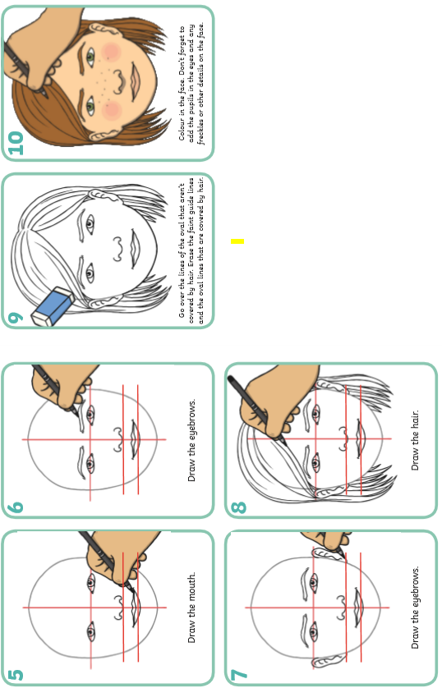
Friday English AM
Now see if you can follow the instructions
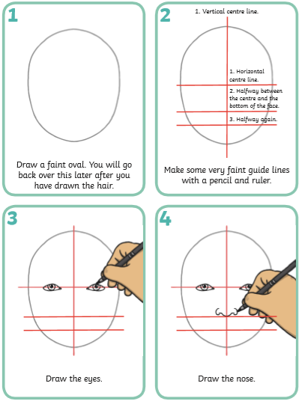

Science AM
Sort and Compare – what makes them different
Birds | Mammals
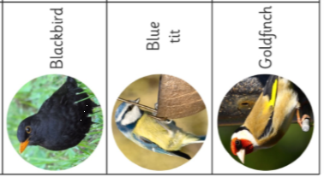
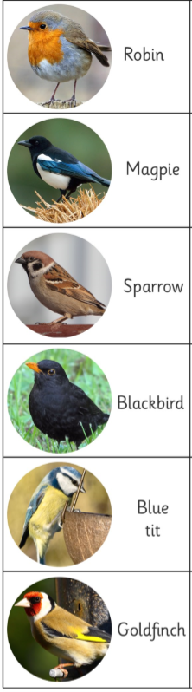
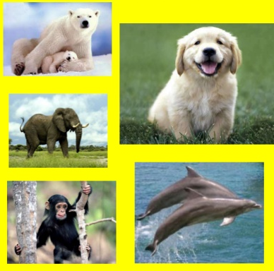

Phonics AM
aw | ew=oo | oe

Retrieval Quiz PM – A, B, C cards needs

- Which of these is a mammal?
- Which of these is a bird?
- What coin is this?
- What time is this?
- Is this picture showing something a. friendly or b. unfriendly?
- What unit of measure have we been measuring on a ruler with?
- Is the word ‘first, second, then, next’ a. time adverb or b. verb?
- What digraph can you see?



