

**Home Learning Pack**

Year 5;

Week Beginning 18.01.21



**Home Learning Links**

**Oak National Academy**

Oak National Academyis an online classroom and resource hub. It provides high-quality video lessons and resources to support teachers, parents and pupils.

[www.thenational.academy](http://www.thenational.academy)

**BBC Bitesize**

With BBC Bitesize it is easy to keep learning at home. You **can access regular daily lessons in English, maths and other core subjects.**

https://www.bbc.co.uk/bitesize

**World Book Online**

World Book online have just made their fabulous collection of over 3,000 e-books and audiobooks available for free for children to access at home. They have books suitable for all ages. Click on the following link to access them.

https://worldbook.kitaboo.com/reader/worldbook/index.html?usertoken=Mjk5MzQ6MTpJUjA5MjAxNjoyOmNsaWVudDE2OTc6MTY5NzoyMjE2Mjg4OjE6MTU4NDM4MDExMzA2Mjp1cw%3D%3D

**Read Works.org**

Read Works offers access to 3000+ comprehension for all age groups. Just sign up for a free account to access fantastic texts.

https://www.readworks.org/

**Tutortastic**

An online platform with tutorials and videos for home learning.

https://www.tutortastic.co.uk/blog/homelearning

**Education Quizzes**

A series of short quizzes for children to complete related to the National Curriculum subjects. Just select KS1 for Reception, Year 1 & Year 2 and select KS2 for Years 3-6.

https://www.educationquizzes.com/ks1/

**Top Marks**

A range of activities here but especially good interactive activities for maths.

https://www.topmarks.co.uk/

**Classroom Secrets**

Classroom Secrets Kids is offering free access to everyone until the end of April 2020. The platform is aimed at primary aged children and covers subjects such as maths, reading, grammar and spelling. The platform is really child-friendly so that they're able to access it on their own. There are a load of games and interactive activities from phonics to SATs

https://kids.classroomsecrets.co.uk/

**National Geographic**

National Geographic is a great platform for learning and it’s totally free. There are online games, resources and competitions, too.

<https://www.natgeokids.com/uk/teacher-category/primary-resources/>

**Reading Eggspress**

Reading Eggspress has lots of reading activities including comprehension and retrieval questions to have a go at. Your child’s Username and Password should be written in his Homework Book.

[**https://readingeggspress.co.uk/?_ga=2.107706762.961348329.1601363904-660844018.1598947512**](https://readingeggspress.co.uk/?_ga=2.107706762.961348329.1601363904-660844018.1598947512)

**Top Marks – Division**

We have been learning about division this week, mostly looking in-depth at partitioning and we will transition into using the short method for division. Here are some great maths games to play on Laptops or iPads.

<https://www.topmarks.co.uk/Search.aspx?q=division>

**Times Tables Rockstars**

This is a great times tables game, practice all of the tables up to 12 x 12. Log- in should be in Homework book/ Reading diary.

[**https://ttrockstars.com/**](https://ttrockstars.com/)

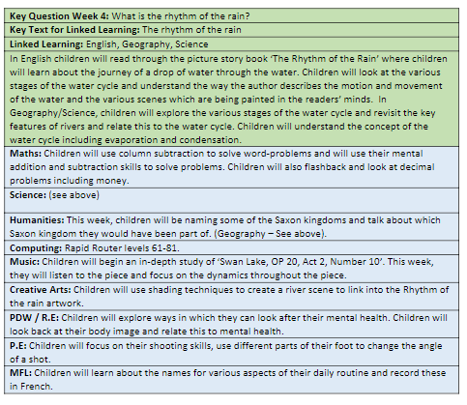

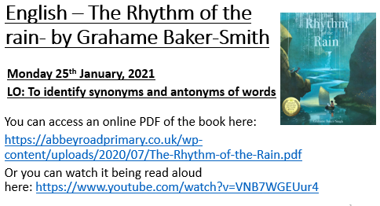

You can access an online PDF of the book here:

<https://abbeyroadprimary.co.uk/wp-content/uploads/2020/07/The-Rhythm-of-the-Rain.pdf>

Or you can watch it being read aloud here: <https://www.youtube.com/watch?v=VNB7WGEUur4>

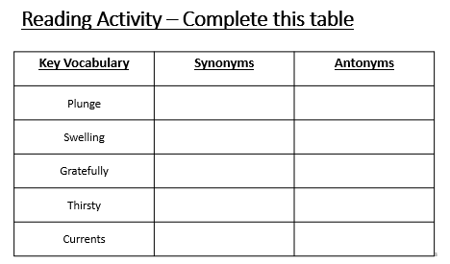

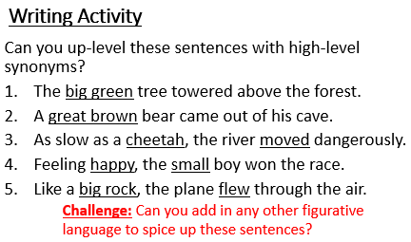

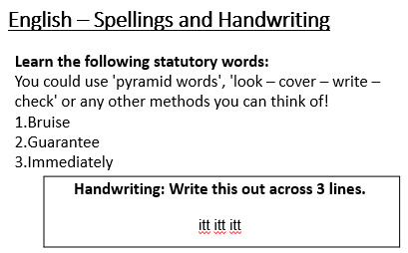

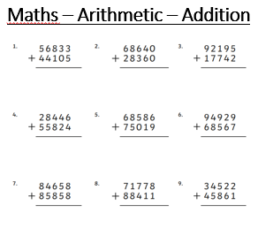

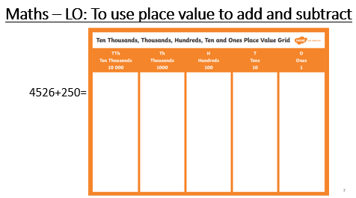

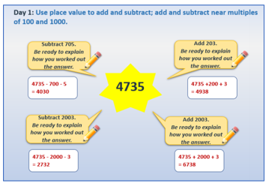

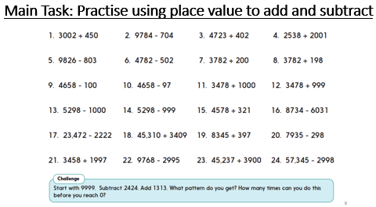

**History**

Here is a short Youtube clip of the Anglo-Saxon Heptarchy (Seven Kingdoms) which we will be learning about today. <https://www.youtube.com/watch?v=Co3POYbGHfQ>

Look at this page on BBC Bitesize where you will find oodles of information about the different Anglo-Saxon kingdoms in England:

<https://www.bbc.co.uk/bitesize/topics/zxsbcdm/articles/zqrc9j6>

**Main Task:** Using your online research, can you identify the 7 different kingdoms of Anglo-Saxon England?

Colour each kingdom in a different colour and label it.

**Anglo-Saxon Kingdoms**



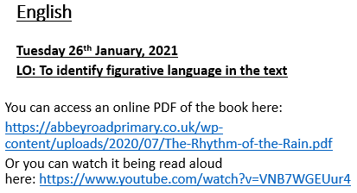

You can access an online PDF of the book here:

<https://abbeyroadprimary.co.uk/wp-content/uploads/2020/07/The-Rhythm-of-the-Rain.pdf>

Or you can watch it being read aloud here: <https://www.youtube.com/watch?v=VNB7WGEUur4>

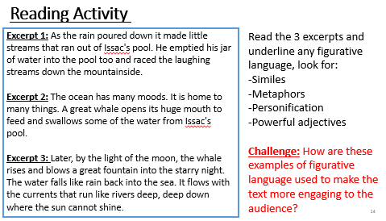

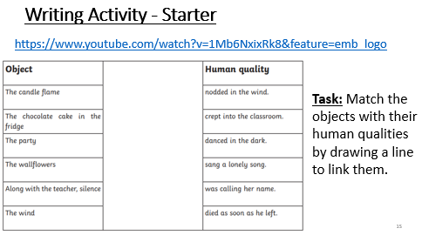

<https://www.youtube.com/watch?v=1Mb6NxixRk8&feature=emb_logo>

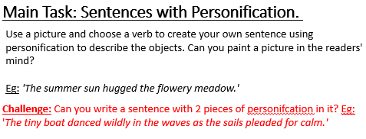

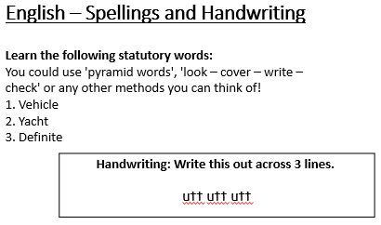

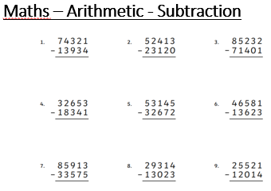

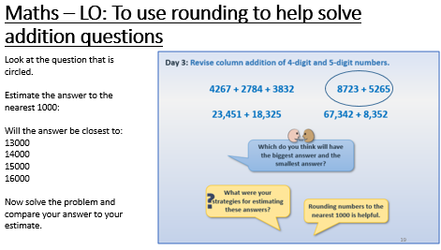

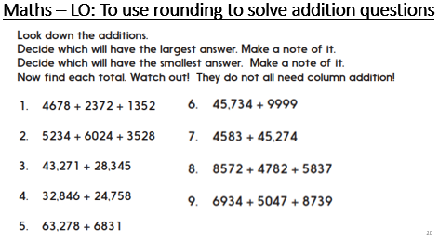

**Science**

**LO: To identify features of a river.**

<https://www.bbc.co.uk/bitesize/topics/z849q6f/articles/z7w8pg8>

or Google:  BBC Bitesize- Rivers

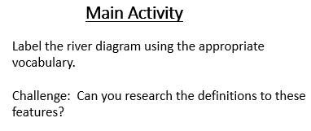



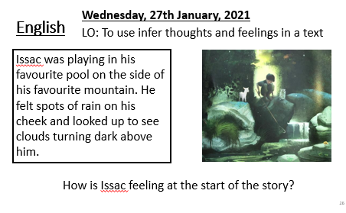

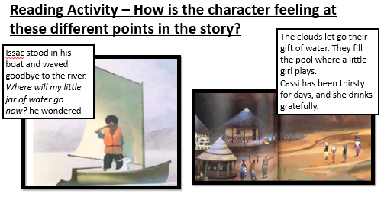

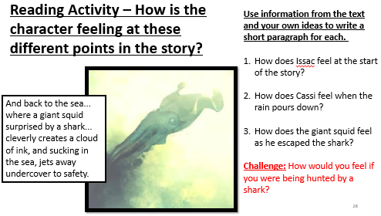

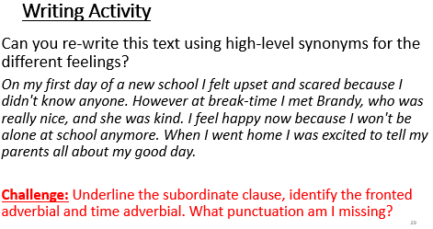

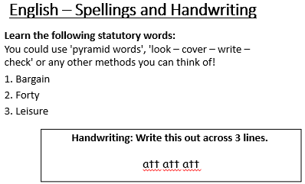

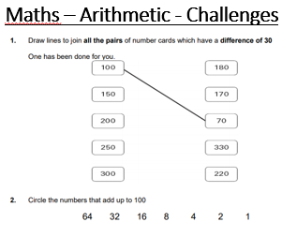

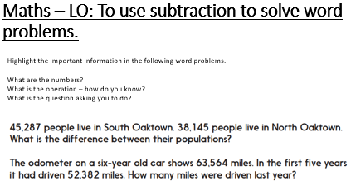

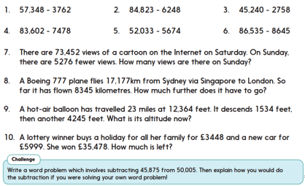

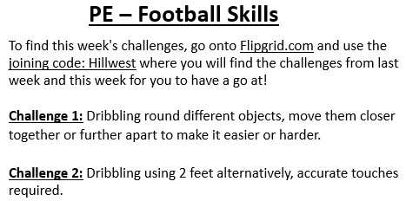



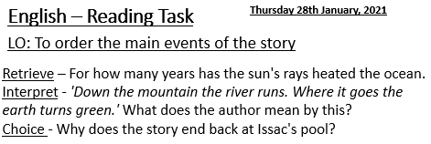

You can access an online PDF of the book here:

<https://abbeyroadprimary.co.uk/wp-content/uploads/2020/07/The-Rhythm-of-the-Rain.pdf>

Or you can watch it being read aloud here: <https://www.youtube.com/watch?v=VNB7WGEUur4>

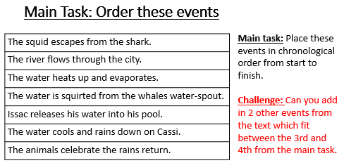

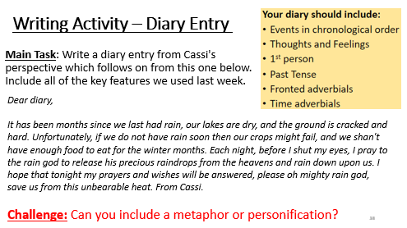

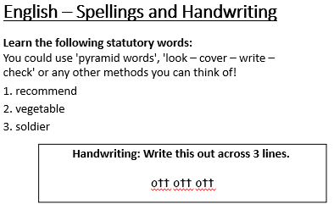

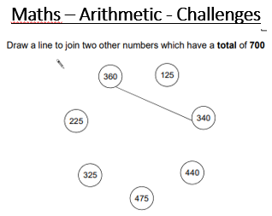

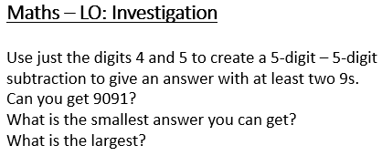

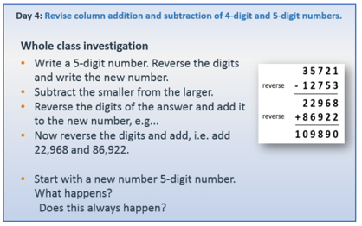



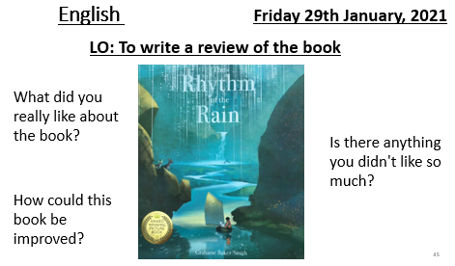

You can access an online PDF of the book here:

<https://abbeyroadprimary.co.uk/wp-content/uploads/2020/07/The-Rhythm-of-the-Rain.pdf>

Or you can watch it being read aloud here: <https://www.youtube.com/watch?v=VNB7WGEUur4>

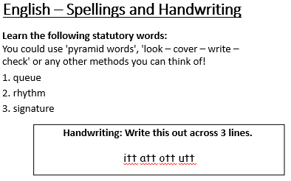

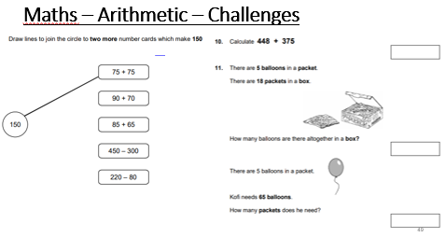

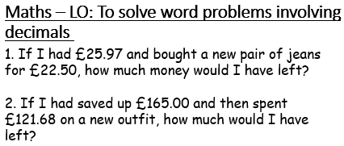

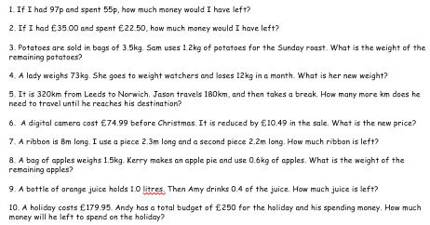

**French – Definite and Indefinite articles**

Visit BBC Bitesize French:

<https://www.bbc.co.uk/bitesize/subjects/z39d7ty>

Then watch the video: French grammar: Indefinite and definite articles

Have a go at the Quiz at the bottom of the page.

Learn how to juggle:

<https://www.youtube.com/watch?v=dCYDZDlcO6g&feature=emb_logo>

**Or**

Learn how to draw a car:

<https://www.youtube.com/watch?v=jLJc8IVmC6s>

**Or**

Learn how to make a hidden door in Minecraft:

<https://www.youtube.com/watch?v=H4Qd6z49XZU>

**PDW – Can you learn a new skill?**