

Home Learning Pack
Year 1
Week Beginning 18.01.21



Home Learning Links

Oak National Academy
Oak National Academy is an online classroom and resource hub. It provides high-quality video lessons and resources to support teachers, parents and pupils.
www.thenational.academy

BBC Bitesize
With BBC Bitesize it is easy to keep learning at home. You can access regular daily lessons in English, maths and other core subjects.
https://www.bbc.co.uk/bitesize

Phonics English Hubs
Online phonics lessons for the Letters and Sounds phonics programme.
https://www.wandleenglishhub.org.uk/lettersandsounds

World Book Online
World Book online have just made their fabulous collection of over 3,000 e-books and audiobooks available for free for children to access at home. They have books suitable for all ages. Click on the following link to access them.
https://worldbook.kitaboo.com/reader/worldbook/index.html?usertoken=Mjk5MzQ6MTpJUjA5MjAxNjoyOmNsaWVudDE2OTc6MTY5NzoyMjE2Mjg4OjE6MTU4NDM4MDExMzA2Mjp1cw%3D%3D

Read Works.org
Read Works offers access to 3000+ comprehension for all age groups. Just sign up for a free account to access fantastic texts.
https://www.readworks.org/

Beanstalk
Beanstalk website is packed with lots of interactive materials for children aged 1 to 6. They are offering free access to all families during the COVID-19 pandemic.
https://beanstalk.co/

Tutortastic
An online platform with tutorials and videos for home learning.
https://www.tutortastic.co.uk/blog/homelearning

Education Quizzes
A series of short quizzes for children to complete related to the National Curriculum subjects. Just select KS1 for Reception, Year 1 & Year 2 and select KS2 for Years 3-6.
https://www.educationquizzes.com/ks1/

Top Marks
A range of activities here but especially good interactive activities for maths.
https://www.topmarks.co.uk/

Classroom Secrets
Classroom Secrets Kids is offering free access to everyone until the end of April 2020. The platform is aimed at primary aged children and covers subjects such as maths, reading, grammar and spelling. The platform is really child-friendly so that they're able to access it on their own. There are a load of games and interactive activities from phonics to SATs
https://kids.classroomsecrets.co.uk/

National Geographic
National Geographic is a great platform for learning and it’s totally free. There are online games, resources and competitions, too.
https://www.natgeokids.com/uk/teacher-category/primary-resources/

Reading Eggs

NOTICES FOR PARENTS
Next week we will be tasting porridge with different toppings and making porridge by following instructions. If you could do this to support learning that would be fab (if not do not worry), photo evidence in homework book.

Zoom Timetable
Monday | AM  English, PDW and Phonics | PM  Maths, Geography and DT
Tuesday | AM  English, PDW and Phonics | PM  Maths, Computing and reading
Wednesday | AM  English, PDW and Phonics | PM  Maths, Science and DT
Thursday | AM  English, PDW and Phonics | PM  Maths, RE and History
Friday | AM  English and Maths | PM  Retrieval Quiz

Key Question Week 3: Who’s been sitting in my chair?
Key Text for Linked Learning: Goldilocks and the Three Bears
Linked Learning: English, PDW, D&T and History.
This week, the children will become Police Investigators by helping to solve the mystery crime that occurs in ‘Goldilocks and the Three Bears’. The children will be reading the text, focussing on inferring characters’ feelings from different parts of the text; such as how do the Bears feel when Goldilocks eats their porridge. Looking at extending their knowledge on feelings other than happy, sad, anger etc. Children will think about a time they were angry and then identify strategies to help manage feelings in future situations. Children will be completing a WANTED poster about Goldilocks using their knowledge and understanding of adjectives to describe her features, a word mat will be used to expand their range of vocabulary. Once Goldilocks has been found, the children will be writing a list of questions to ask Goldilocks and then will be given the opportunity to interview our good friend. To conclude our investigations into the ultimate crime, the children will be writing and presenting their findings to the class, using the conjunction ‘because’ to explain their ideas. Having concluded that Goldilocks decided to eat the porridge, children will be exploring where our food comes from and how having a balanced diet is important. Throughout the week, the children will be designing their own healthy meal for Goldilocks, applying their knowledge of a balanced diet. Children will be tasting different types of porridge and evaluating which one they prefer, before recreating their own flavour of porridge. In history, children will sequence events chronologically from their life.
Maths: Children will recognise 1p, 2p, 5p, 10p, £1 coins; Find totals using more than two coins up to 10p in value; Work out what coins can be used to pay an amount up to 10p; Begin to find all possibilities by making an ordered list; Count on in tens from single digit numbers and back; Relate counting on in tens to find 10 more/less than any two-digit number.
Science: Children will be completing their labelled diagrams using scientific vocabulary. ( goldilocks chair)
Geography: Children will use a simple map to identify the location of features and routes.
History: See above
Computing: Children will learn about and be able to talk about being respectful when communicating online and talking face to face.
Music: Children will listen with concentration to different musical pieces and will begin to comment on pitch, tone, tempo, rhythm and dynamics.
Art / Design Technology: See above
PDW: See above
RE: Children will explore the Jewish festival of Hanukkah.
P.E: The children will be taught the skill overarm throwing using different types of balls to practise rolling on the floor to a partner. Once confident the children will practice throwing to each other using this technique. The children will focus on keeping their eye on the ball. The children will be set a 30 second challenge to catch the ball as many times as they can, counting out loud as they go-but only the ones caught count.

English AM
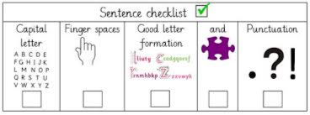
Monday 18th January
To use CL FSp and FS.
To use adjectives independently.
Wanted !

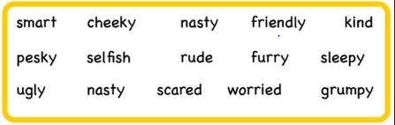

Draw a picture of Goldilocks then write a list of adjective to describe her. Once written can you put them into sentences.
_________________________________________________________________________________________________________________________________________________________________________________________________________________________________________________________________________________________________________________________________________________________________________________________________________________________________________________________________________________________________________________________________________________________________________________________________________________________________________________________________________________________________________________________________________________________________________________________________________________________________________________________

PDW/ English AM
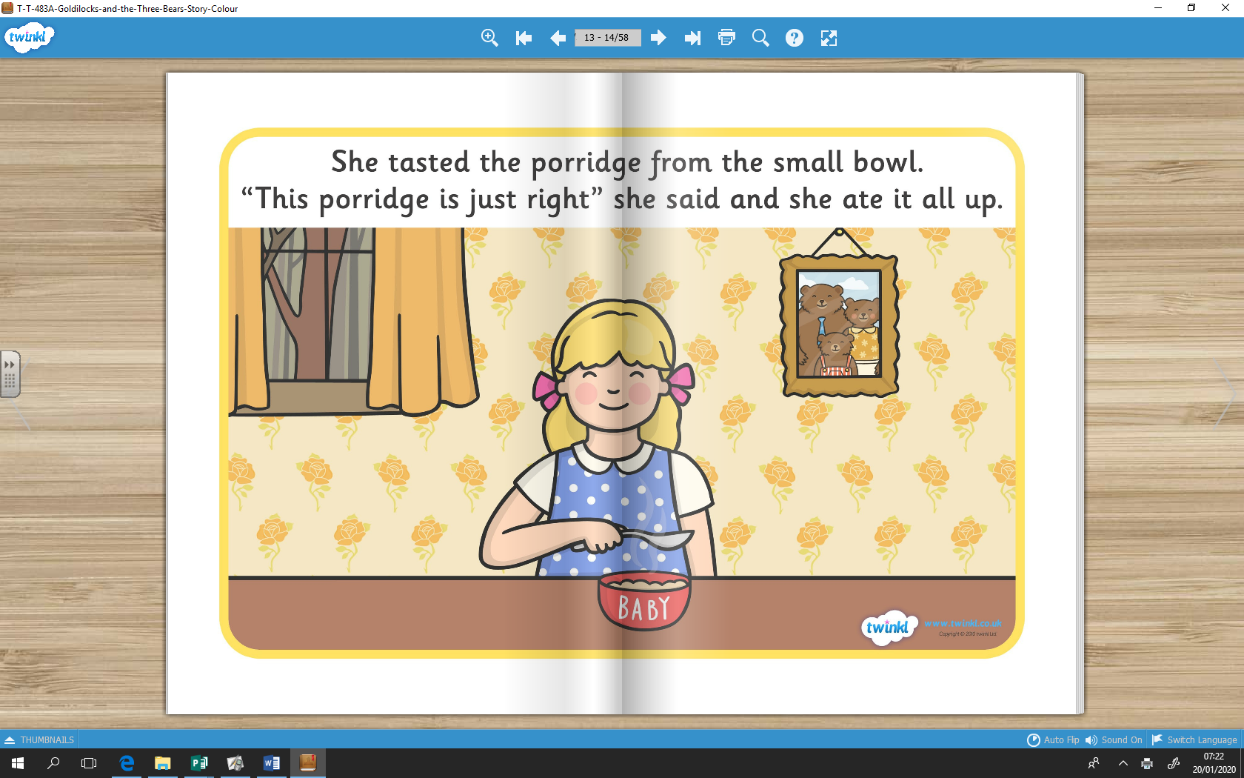
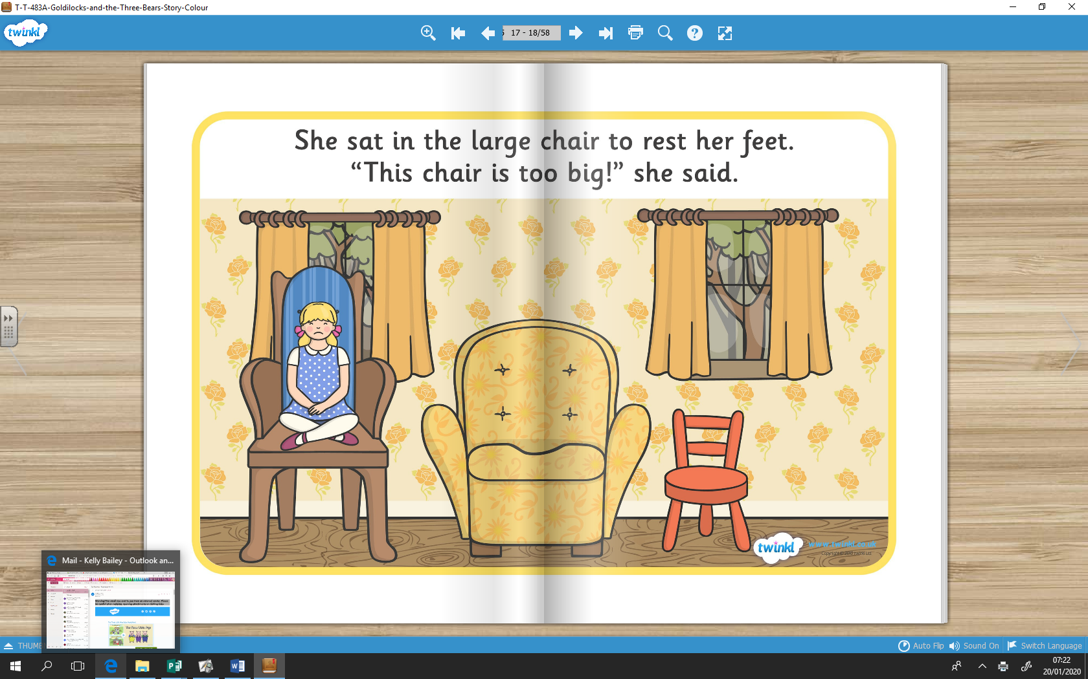
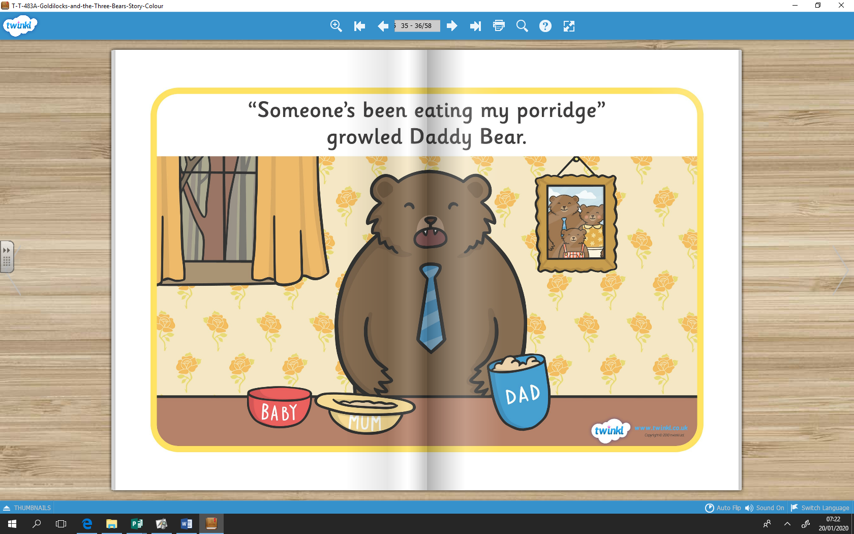
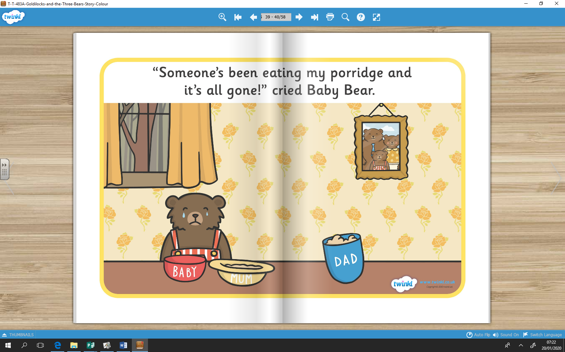
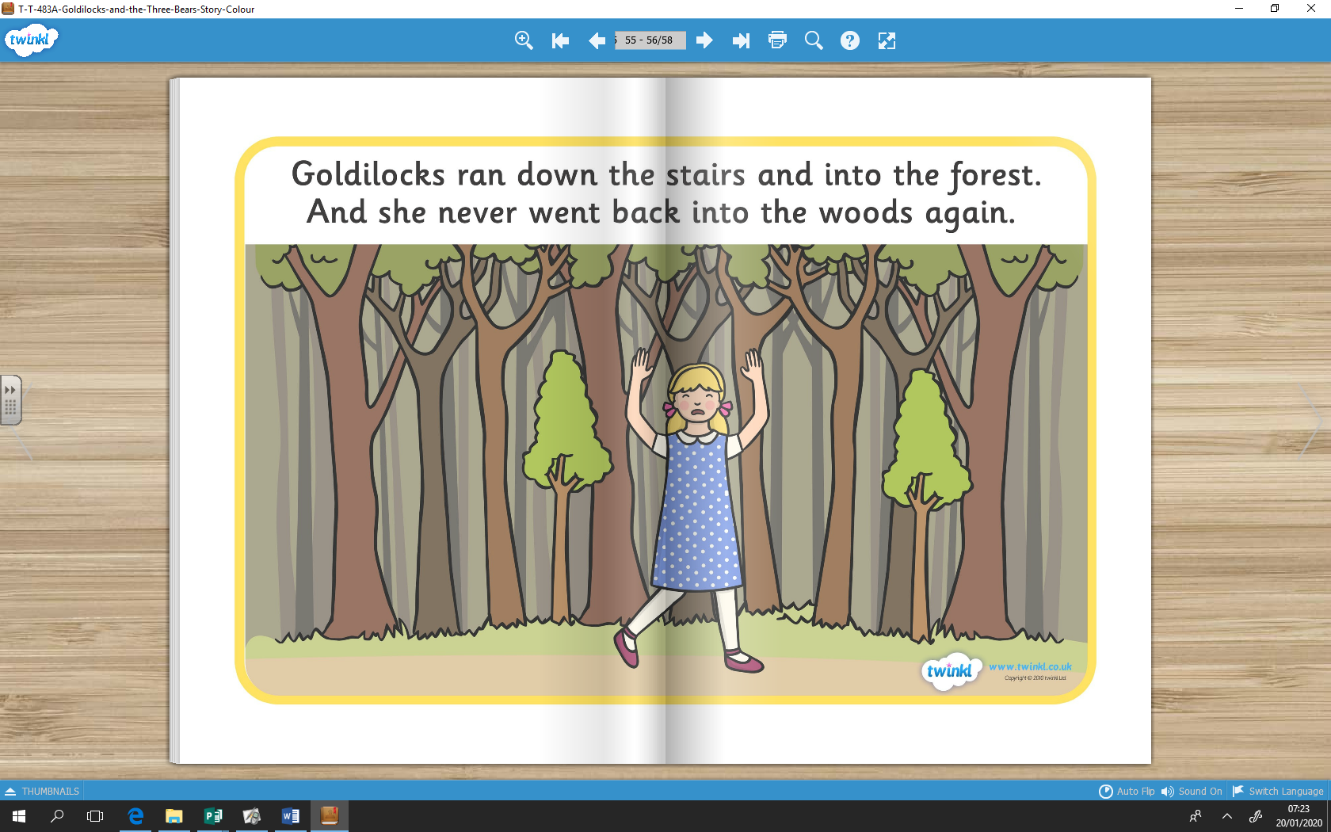
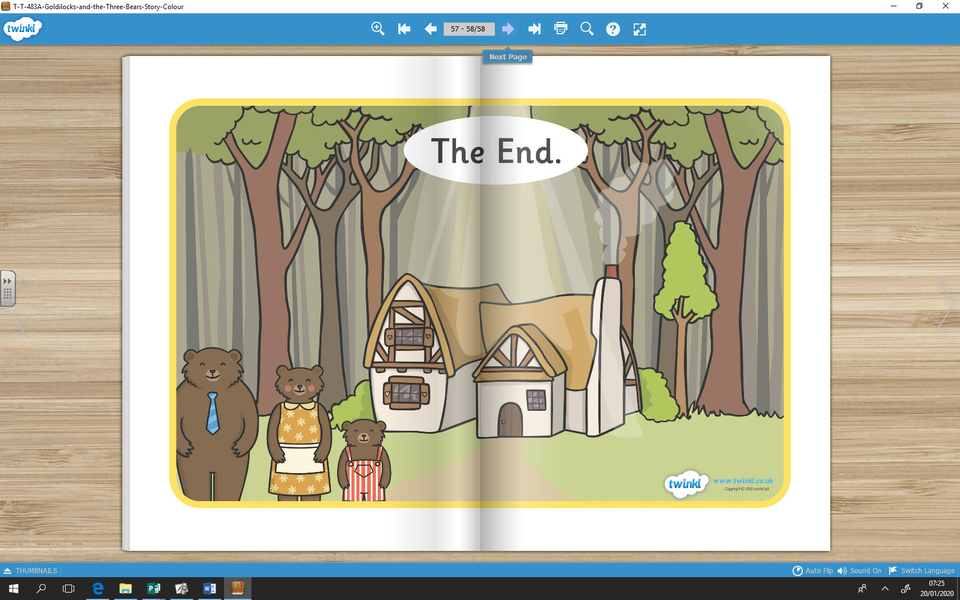

Look at the photos selected from the story, can you write a sentence for each picture about how the character might be feeling and explain why you think this by using ‘because’.
_______________________________________________________________________________________________________________________________________________________________________________________________________________________________________________________________________________________________________________________________________________________________________________________________________________________________________________________________________________________________________________________________________________________________________________________________________________________________________________________________________________________________________________________________________________________________

Phonics AM
Recap: ay, ou, ie, ea, wh and ph
ay | ie | ea | ie | wh | ph
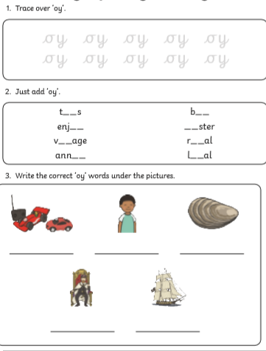

Oy - https://www.youtube.com/watch?v=aodJQr-WJLk
https://www.youtube.com/watch?v=y6nPjMusMVM
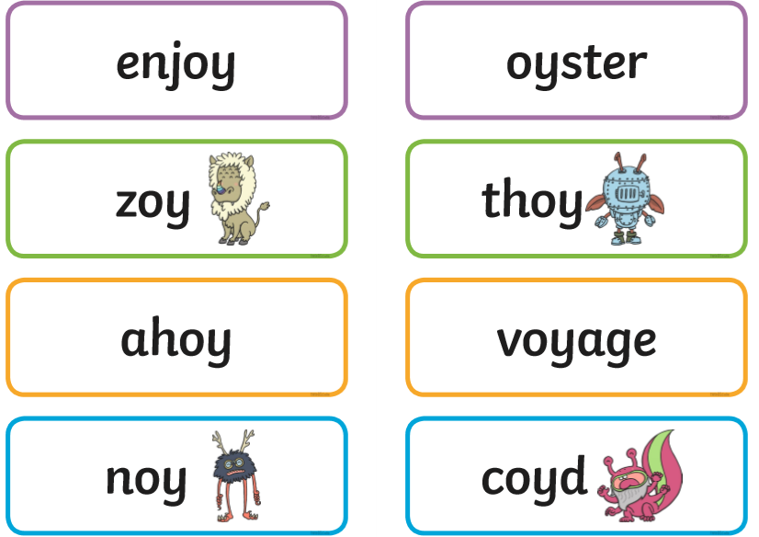
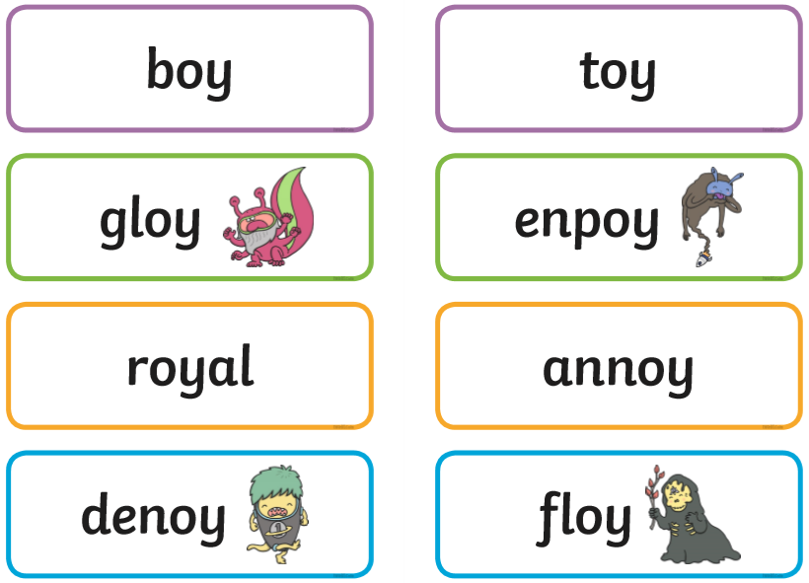

Sort these into trash and treasure.
Once completed them write the real words into a sentence and draw a picture to match.

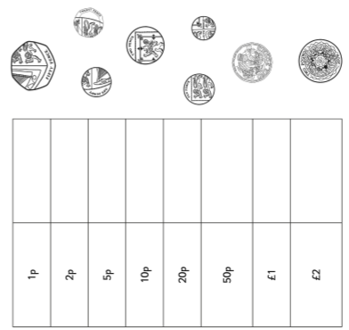
Maths PM
Cut and Stick these coins into the correct box.

Geography PM
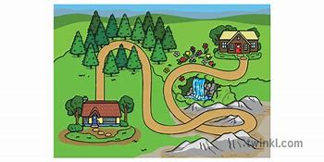

What feature can you see on a map? (Eg. Road) Make a list
__________________________________________________________________________________________________________________________________________________________________________________________________________________________________________________________________________________________________________________________________________________________________________________________________________________________________________________________________________________

DT PM
Healthy Foods | Unhealthy Foods
Healthy vs Unhealthy
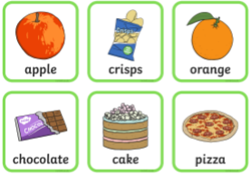
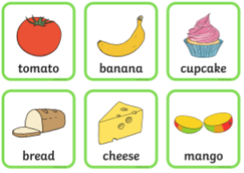
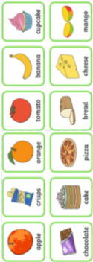

Cut and stick the healthy and unhealthy foods into the correct box. Once completed talk about why they might be in these categories of healthy and unhealthy.
Tuesday AM
English

Look at the pictures – What questions would you like to ask these characters?
Remember to punctuate your questions with a ‘?’ at the end.
Goldilocks | Daddy Bear | Mommy Bear | Baby Bear

PDW AM

What feeling is this?
__________________________________________________________________________________________________
Draw a picture of when you have felt angry. (Miss Beardmore gets angry when her sister take her things without asking.)

Phonics AM
Using the words you have made in the ‘ir’ digraph spotter, can you put the words into sentences? (Even if they don’t have the ‘ir’digraph in)
_____________________________________________________________________________________________________________________________________________________________________________________________________________________________________________________________________________________________________________________________________________________________________________________________________________________________________________________________________________________________________________________________________________________________________________________________________________________________________________________________________________________________________________________________________________________________________________________________________________________________________________________________________________________________________________________________________________________________________________________________________________________________________________________________________________________________________________________________________________________________________________________________________________
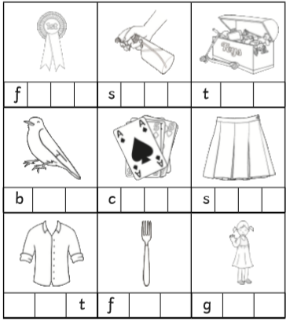
‘ir’ digraph - https://www.youtube.com/watch?v=7ta_KKUU-98
Maths PM
Use the coins below to make your own coin number sentences; what number sentences can you create and can you work them out…

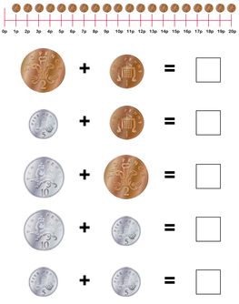
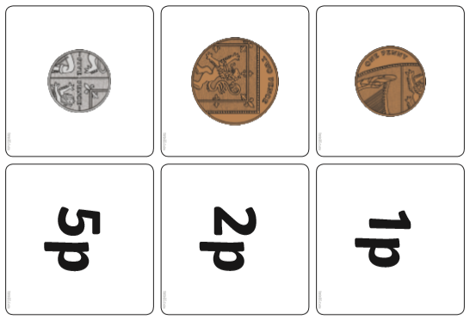
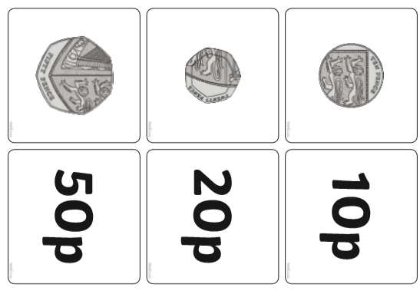

Computing PM
How can we be respectful online?
https://www.youtube.com/watch?v=aPyax5kJaNg
https://www.webroot.com/au/en/resources/tips-articles/getting-and-giving-respect-online

Using your manners online to other people
Respect Online

Reading PM

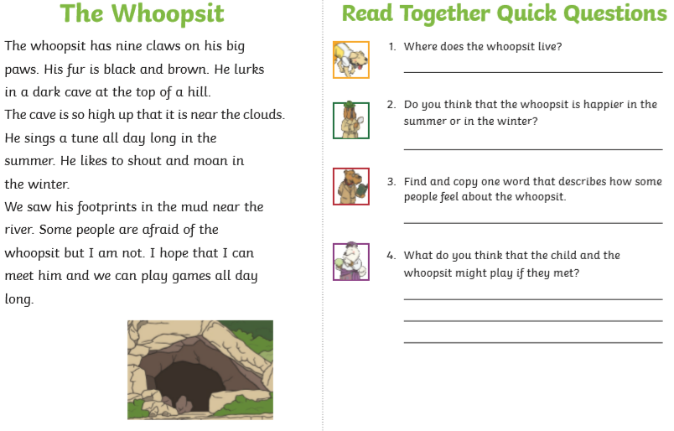

Wednesday AM
English
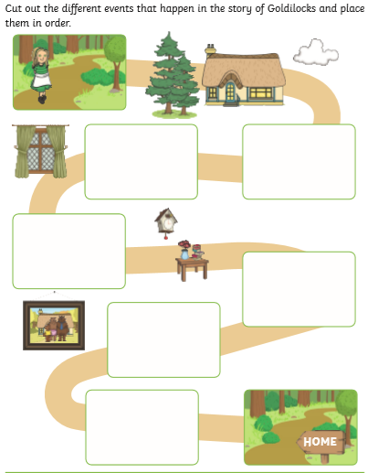
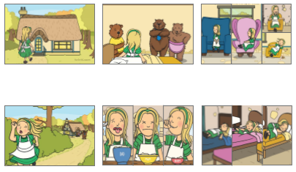
Sequence the story map.
Once completed, rewrite the story of Goldilocks and the Three Bears – remember to use story language such as ‘once upon at time…’ and ‘the end’ etc.
Ensure that you are remembering the features of a sentence as well; capital letters, finger spaces and full stops.

PDW AM
On Monday we discussed what this emotion is and a time when you have felt angry. Today we are going to look at how we can overcome feeling angry by looking at strategies to help us stay calm.
Video - https://www.youtube.com/watch?v=eNSeqQIBv5o
What can I do to manage my anger?
___________________________________________
___________________________________________
___________________________________________
___________________________________________
___________________________________________
___________________________________________

___________________________________________
___________________________________________
___________________________________________

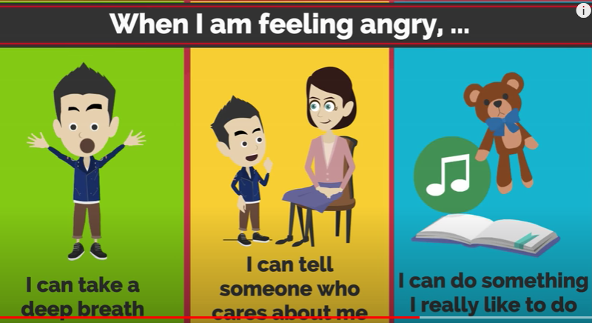

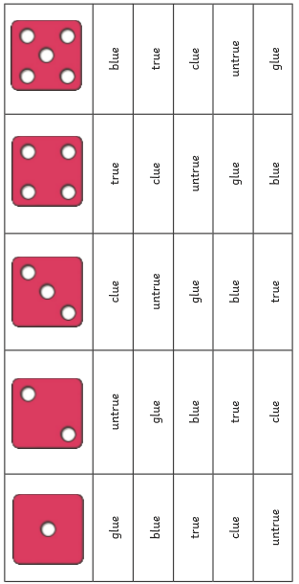
Phonics AM
‘Ue’ = oo https://www.youtube.com/watch?v=BCeE3B_tAq8
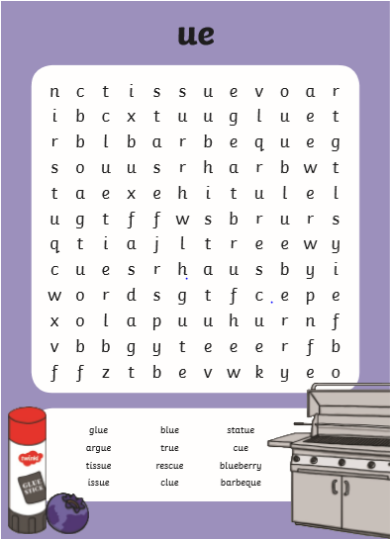

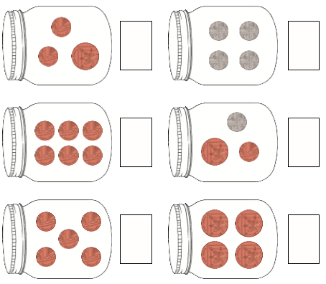
Wednesday PM
Maths – Using your knowledge of money can you work out how much is in each jar?
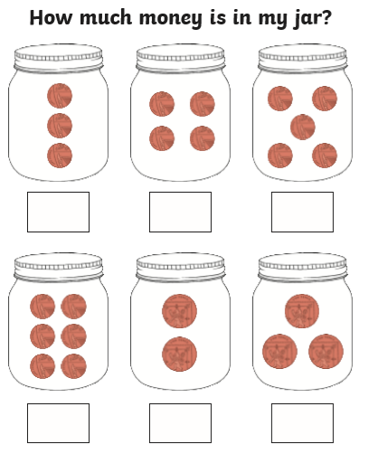

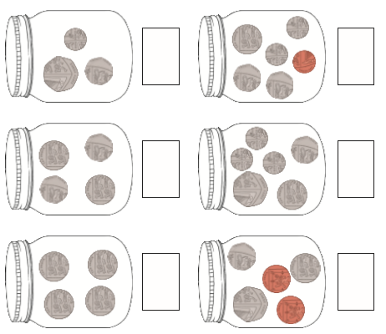

Science PM
Using your knowledge of materials, can you answer these questions using scientific vocabulary?

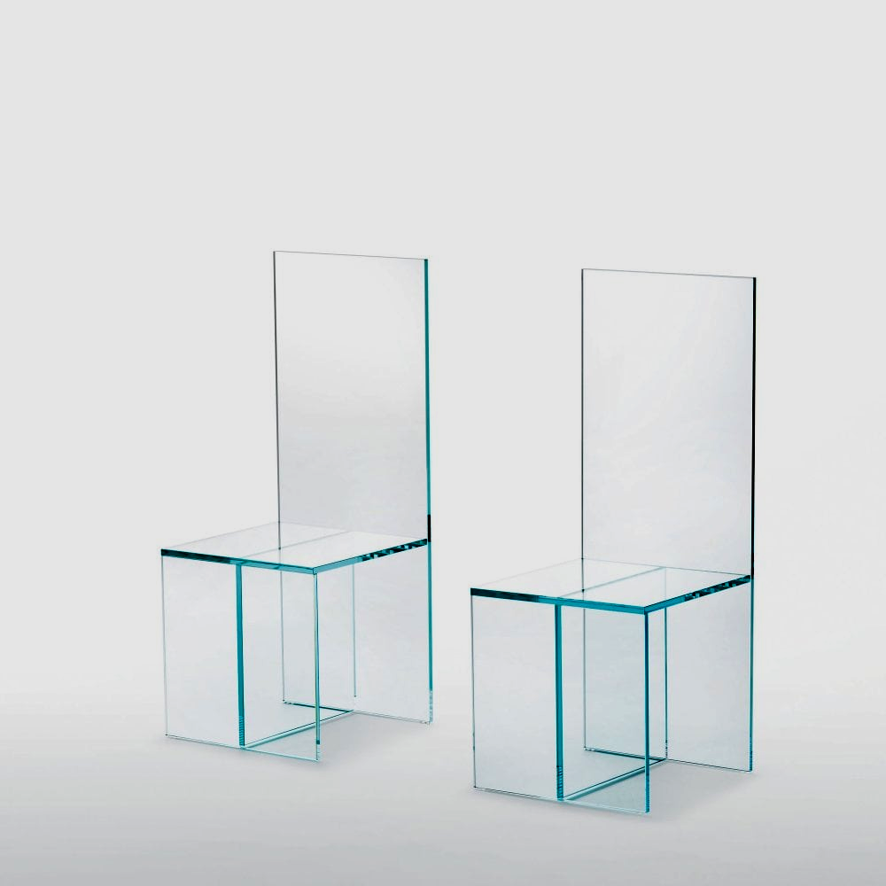
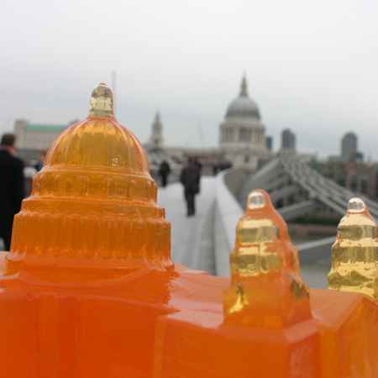
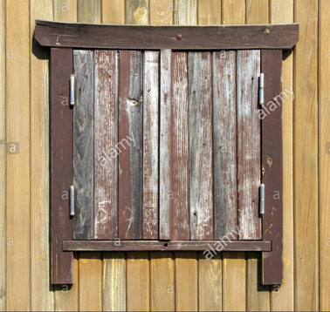
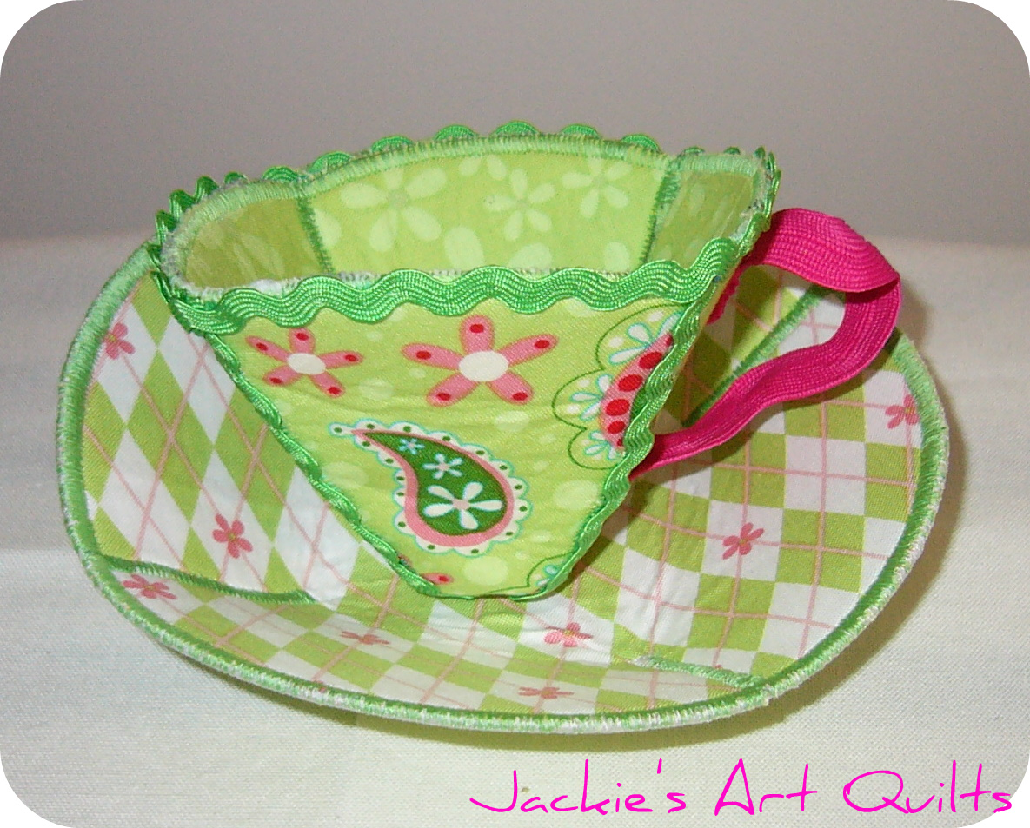
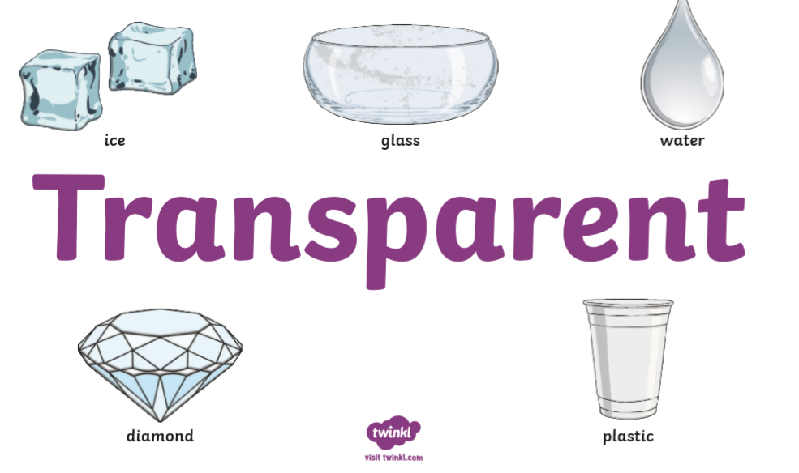
Would you sit on a glass chair?
Would you build a house of jelly?
Would you make a window out of wood?
Would you make a cup out of fabric?
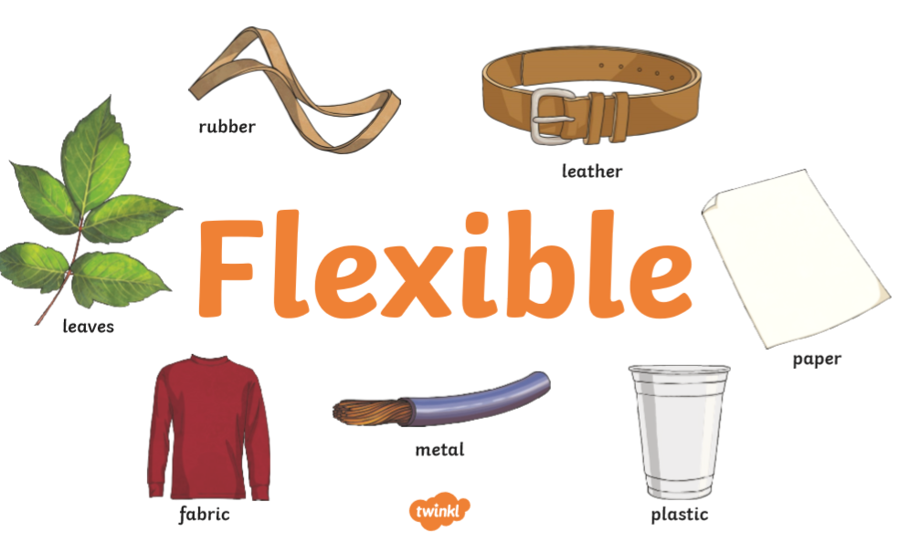

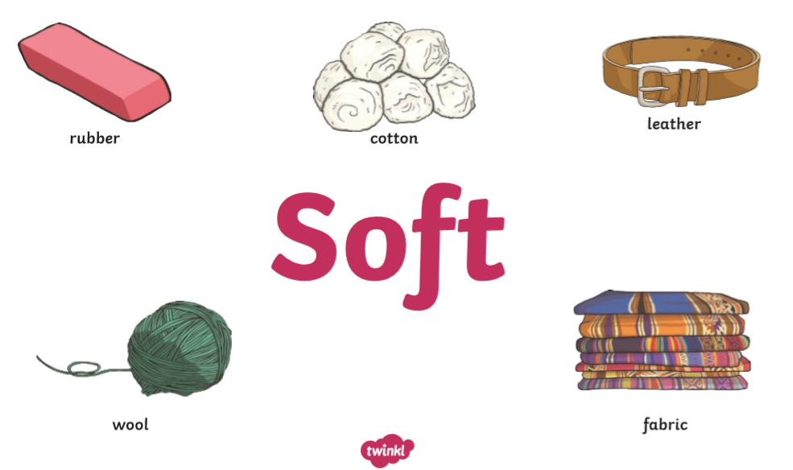

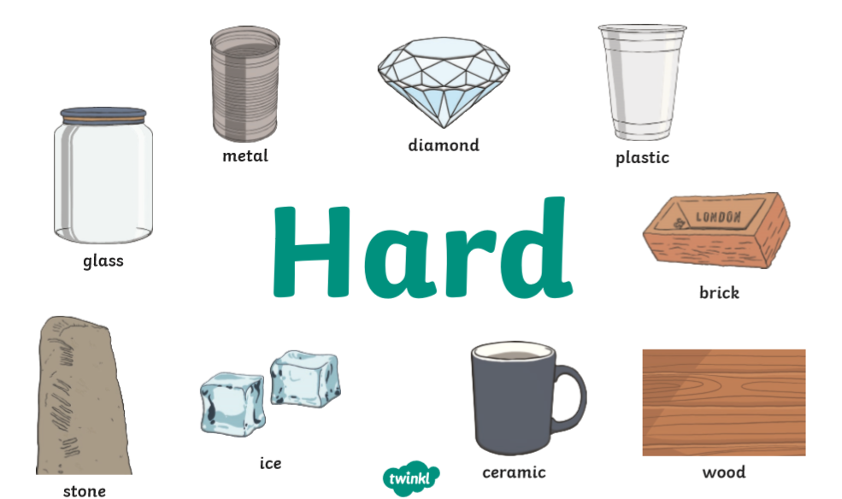

DT PM
Using your knowledge of foods that are healthy, can you design your own healthy meal that Goldilocks could eat?

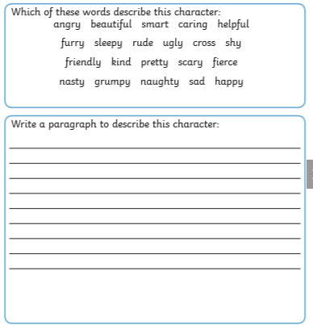
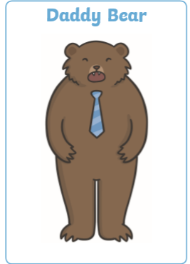
Thursday AM
English – Using your knowledge of adjectives, write some sentences about the Three Bears. Use the word mats to help you but also think of some of your own.

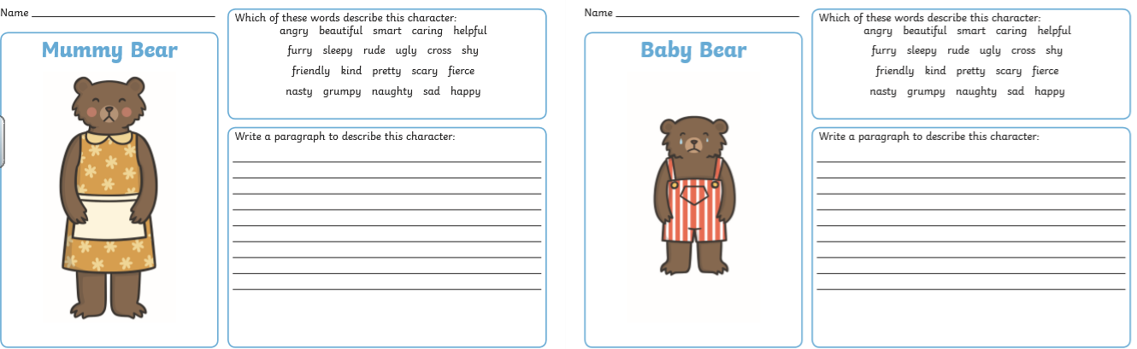
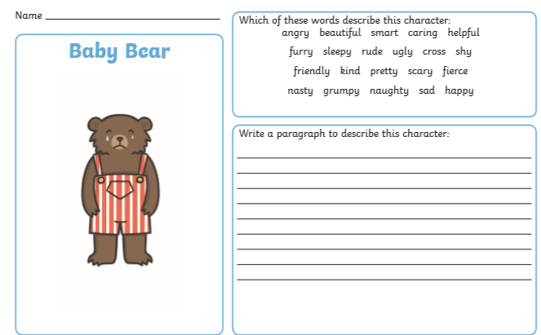
PDW AM
Feelings – What other words can we use for these feelings?
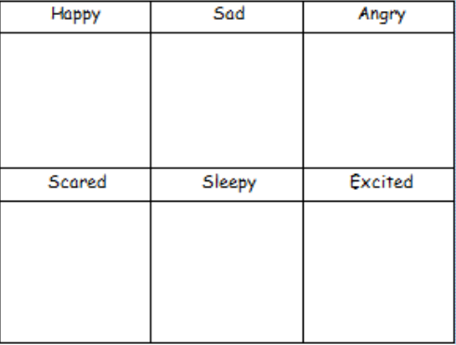
Using a dictionary or using your computer to google the definition – how many other words can you find for each?

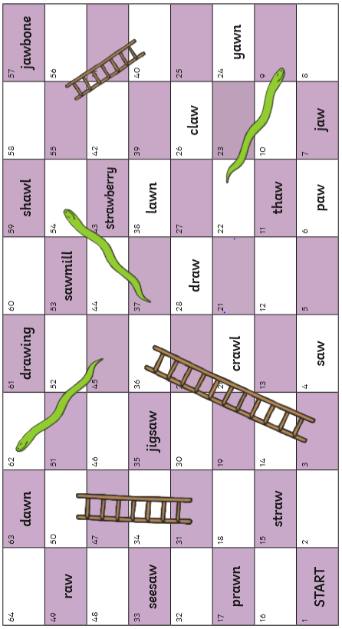
Phonics AM
‘aw’ digraph - https://www.youtube.com/watch?v=wM5Spk0yJt8

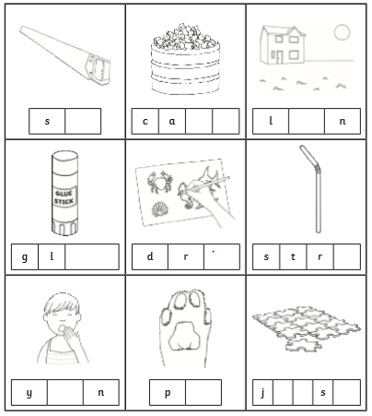

Math PM
Counting in tens from any given number; remember when counting in tens the only number that changes is the number in the tens column (if need more help ask them about tens and ones)
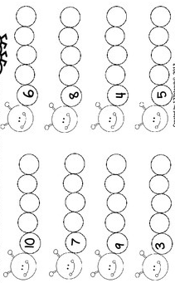
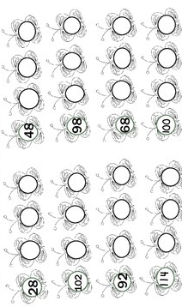

History PM
Chronological order – think about events in your life by using photos and discussions with your family. Can you put them in order from past events to present?
A long time ago… |  | Before… |  | Today…

Once completed can you then write sentences using the history vocabulary to explain what you were doing?
Vocabulary - before, after, then, now and a long time ago.
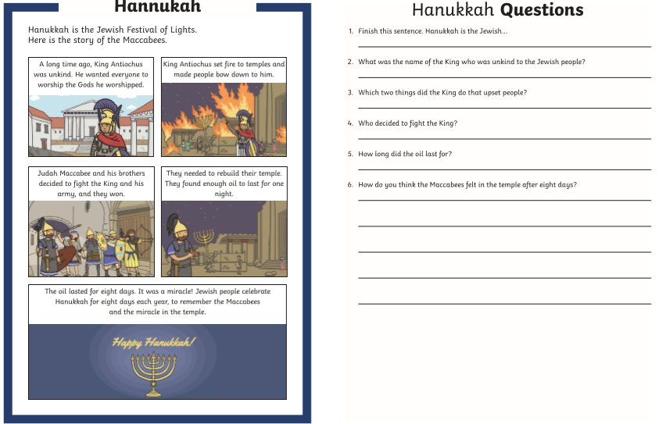
RE PM
Friday AM
English
Write a letter to Goldilocks explaining the wrong choice that she made and tell her how she can make them right by using the conjunction ‘because’.
Example….
Dear Goldilocks,
I have heard that you have made some wrong choice. I hear you have…..
I think that the bears would forgive you if you apologise for….
From
Miss Beardmore
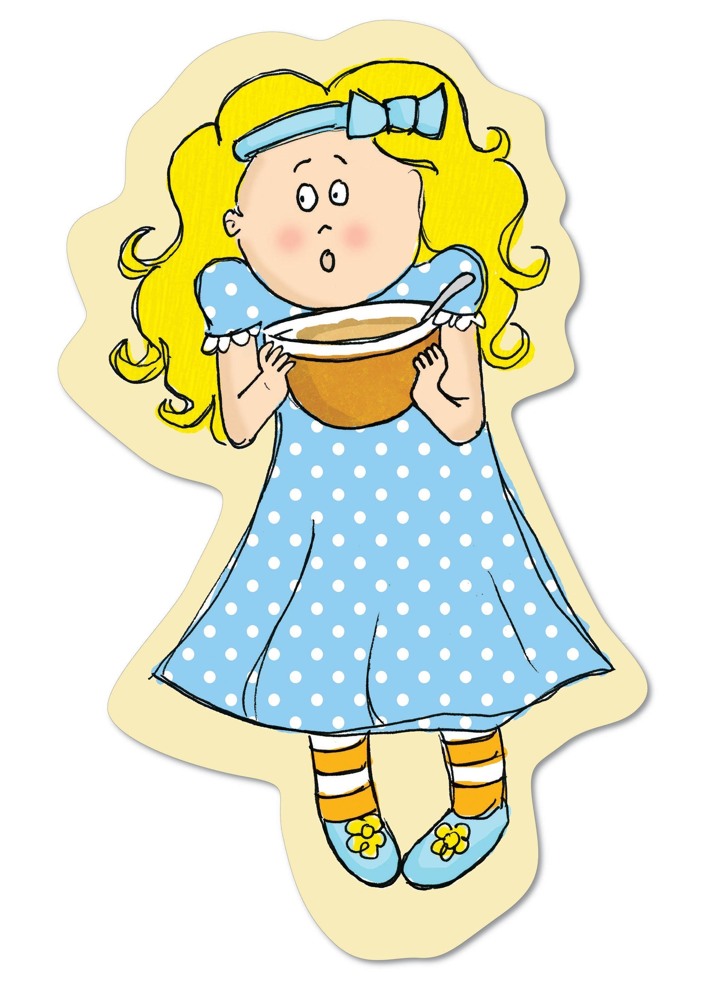

Dear Goldilocks,
________________________________________________________________________________________________________________________________________________________________________________________________________________________________________________________________________________________________________________________________________________________________________________________________________________________________________________________________________________________________________________________________________________________________________________________________________________________________________________________________________________________________________________________________________________________________________________________________________________________________________________________________________________________________________________________________________________________________________________________________________________________________________________________________________________________________________________________

Maths AM
Add the numbers from the tens and one sheet to the first box and count in tens for each.
Tens and Ones recap – once completed then show ten more (counting in tens from any given number).
11

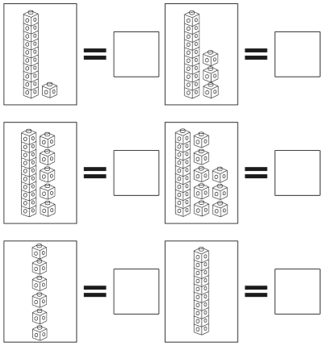

Phonics AM
Recap – write 5 words for each one.
ay | ou | ie | ea
oy | ir | ue | aw
wh | ph | Practise spellings for Autumn 1 and 2, and Spring 1 in your homework books.

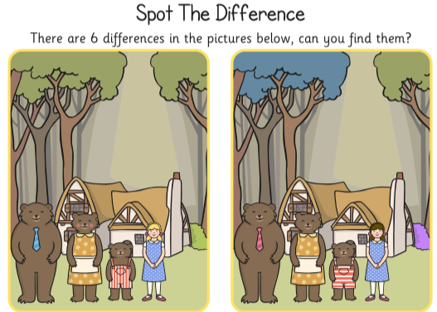

Handwriting Practise


