

**Home Learning Pack**

Reception

Autumn Term Week 8



**Home Learning Links**

**Oxford Owl**

For a limited time, the Oxford reading scheme books we use to support your child’s reading in school and at home are providing free access to selected books. All you need to do it click on the link below and register an email to get reading.

[**https://home.oxfordowl.co.uk/books/free-ebooks/**](https://home.oxfordowl.co.uk/books/free-ebooks/)

**Phonics Play**

This is a great resource that we use in school to support the teaching of phonics. They have a range of games for the children to complete where they will be applying their phonic knowledge. Currently they are providing free access using the following username and password.

Username: march20

Password: home

<https://new.phonicsplay.co.uk/>

**Oak National Academy**

This website has been created by 40 teachers from some of the leading schools across England, backed by government grant funding. Here you can access all of our lessons. Either you can follow a set plan of lessons across a range of subjects, or you can access particular lessons in certain subjects.

<https://www.thenational.academy/online-classroom/reception#schedule>

**Teach your monster to read**

Create a monster and take it on an adventure through a magical world. Travel to exciting places, meet fun characters, play games and win prizes as your monster learns the first steps of reading. Minigames help children to develop speed and accuracy of letter recognition. Lots of blending, segmenting and tricky words. Read for purpose with magical little books. A great way to help your children with reading at home.

The website is free.

<https://www.teachyourmonstertoread.com/>

**White rose maths**

The White Rose Maths Team has prepared a series of five maths lessons for each year group. They add five more each week for the next few weeks. Every lesson comes with a short video showing you clearly and simply how to help your child to complete the activity successfully.

<https://whiterosemaths.com/homelearning/early-years/>

**Letters and Sounds**

Filmed phonics lessons that follow phases 2 to 5 of the Letters and Sounds programme for reception, year 1 and learning to blend. Parent guidance videos.

[**https://www.youtube.com/channel/UCP_FbjYUP_UtldV2K_-niWw**](https://www.youtube.com/channel/UCP_FbjYUP_UtldV2K_-niWw)

**Numberblocks**

We use the Numberblocks to support our teaching of Maths Mastery. Check out the website for clips to help support your child’s maths development.

[**https://www.bbc.co.uk/cbeebies/shows/numberblocks**](https://www.bbc.co.uk/cbeebies/shows/numberblocks)

**World Book Online**

World Book online have just made their fabulous collection of over 3,000 e-books and audiobooks available for free for children to access at home. They have books suitable for all ages. Click on the following link to access them.

https://worldbook.kitaboo.com/reader/worldbook/index.html?usertoken=Mjk5MzQ6MTpJUjA5MjAxNjoyOmNsaWVudDE2OTc6MTY5NzoyMjE2Mjg4OjE6MTU4NDM4MDExMzA2Mjp1cw%3D%3D

**Read Works.org**

Read Works offers access to 3000+ comprehension for all age groups. Just sign up for a free account to access fantastic texts.

https://www.readworks.org/

**Beanstalk**

Beanstalk website is packed with lots of interactive materials for children aged 1 to 6. They are offering free access to all families during the COVID-19 pandemic.

https://beanstalk.co/

**Education Quizzes**

A series of short quizzes for children to complete related to the National Curriculum subjects. Just select KS1 for Reception, Year 1 & Year 2 and select KS2 for Years 3-6.

https://www.educationquizzes.com/ks1/

**Top Marks**

A range of activities here but especially good interactive activities for maths.

https://www.topmarks.co.uk/

**Phonics**

In phonics this week we are learning about the phonemes ff, ss, ll, j. We have been looking for objects starting with these phonemes and practising how to correctly form each grapheme. The following link will help ensure your child is using the correct pronunciation: <https://www.bing.com/videos/search?q=i+phoneme+phonics+video&&view=detail&mid=B6B4FD0AC76D4F86F2EFB6B4FD0AC76D4F86F2EF&&FORM=VRDGAR&ru=%2Fvideos%2Fsearch%3Fq%3Di%2520phoneme%2520phonics%2520video%26qs%3Dn%26form%3DQBVR%26sp%3D-1%26pq%3Di%2520phoneme%2520phonics%2520video%26sc%3D0-23%26sk%3D%26cvid%3D708BA99422D64467BCE8B96F1BBFDA23>

**Use the flashcards below to practise recognising these phonemes.**

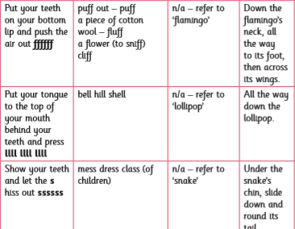

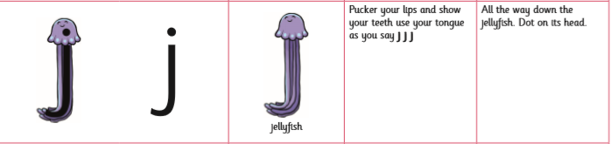

**ll phoneme**

What are these?

Where does the ‘ff’ come in the word?

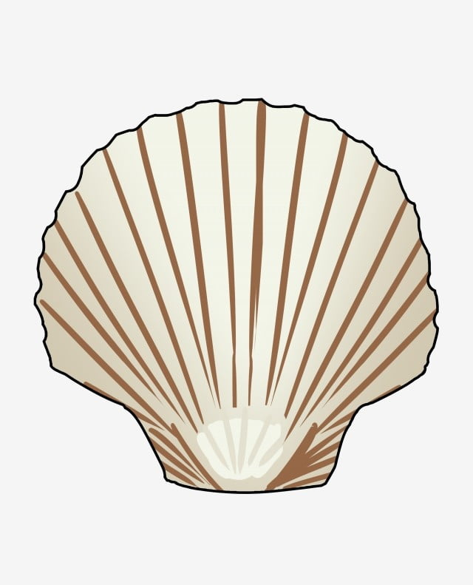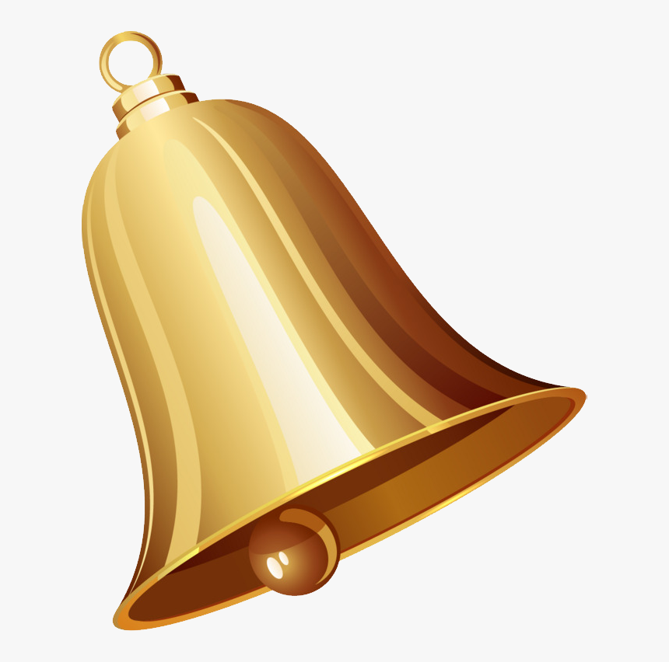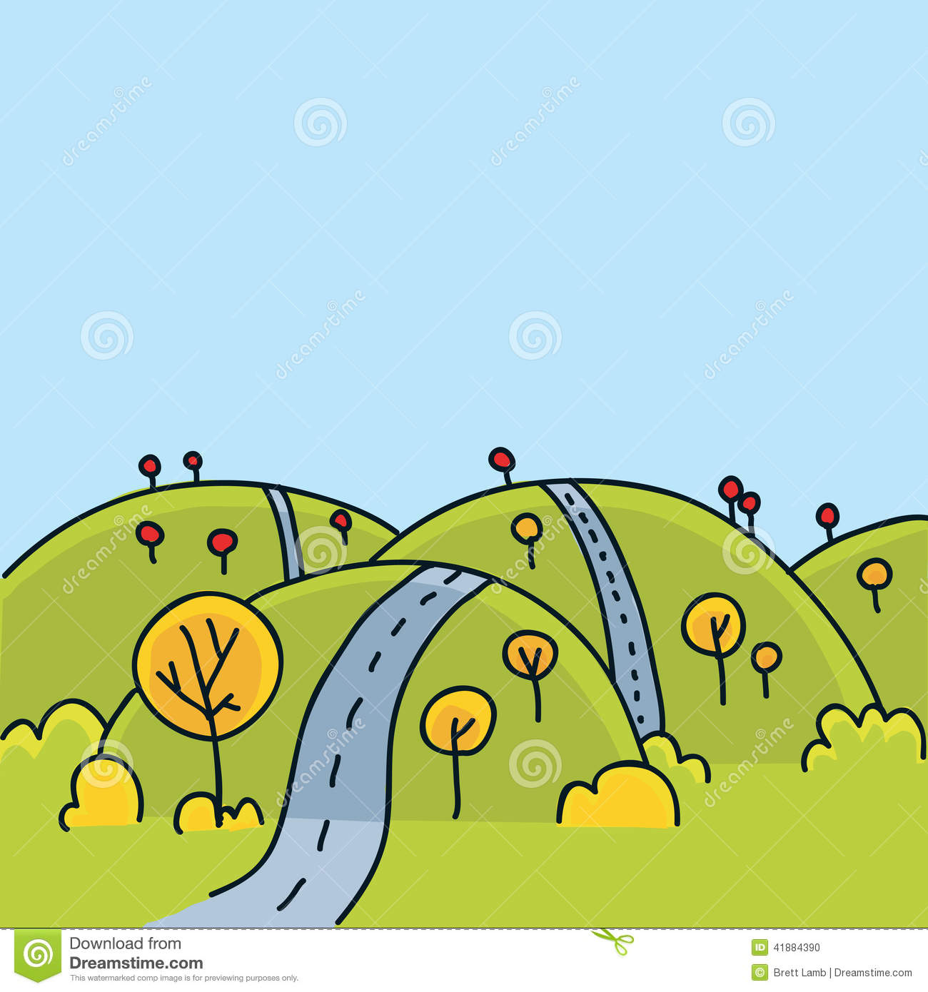

Can you find any other ‘ll’ phonemes words around the houses?

________________________________________________________________________________________________________________________________________________________________________________________________________________________________________________________________________________________________________________________________________________________________________________________________________________________

**ss phoneme**

What are these?

Where does the ‘ss’ come in the word?

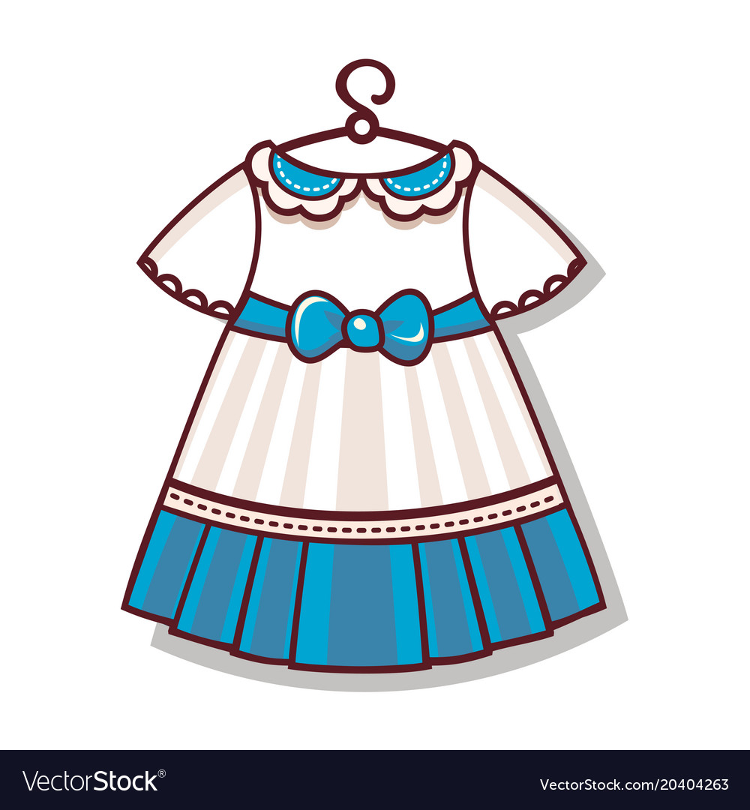

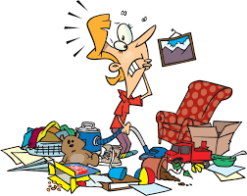

Can you find any other ‘ss’ phonemes words around the houses?

________________________________________________________________________________________________________________________________________________________________________________________________________________________________________________________________________________________________________________________________________________________________________________________________________________________

**j phoneme**

What are these?

Where does the ‘j’ come in the word?

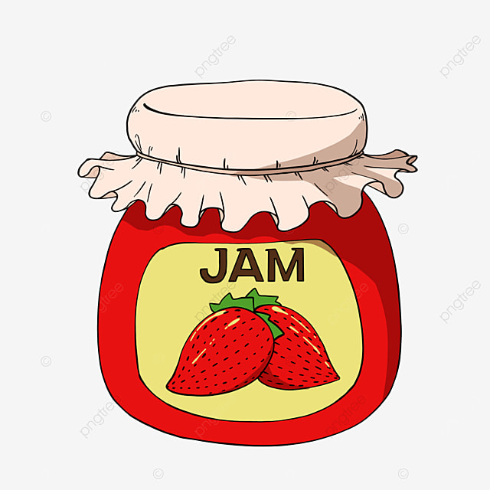

Can you find any other ‘j’ phonemes words around the houses?

________________________________________________________________________________________________________________________________________________________________________________________________________________________________________________________________________________________________________________________________________________________________________________________________________________________

**ff phoneme**

What are these?

Where does the ‘ff’ come in the word?



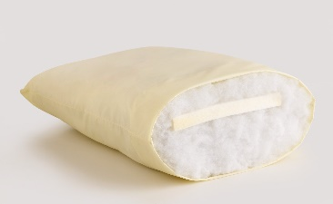



Can you find any other ‘ff’ phonemes words around the houses?

________________________________________________________________________________________________________________________________________________________________________________________________________________________________________________________________________________________________________________________________________________________________________________________________________________________

Hide s, a ,t p, I, n, m, d, g, o, c, k, ck, e, u, and r around the house and see if you can find them and read the phoneme to your family or friends.

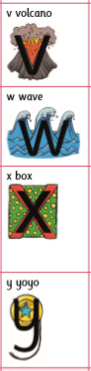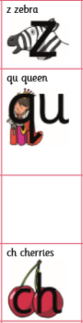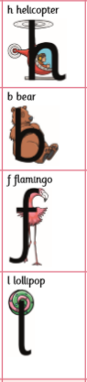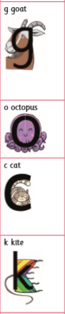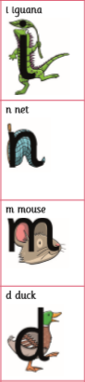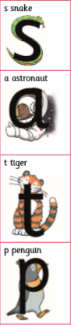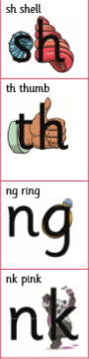

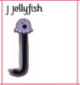



**Maths**

**Colour and design the number blocks number 4**

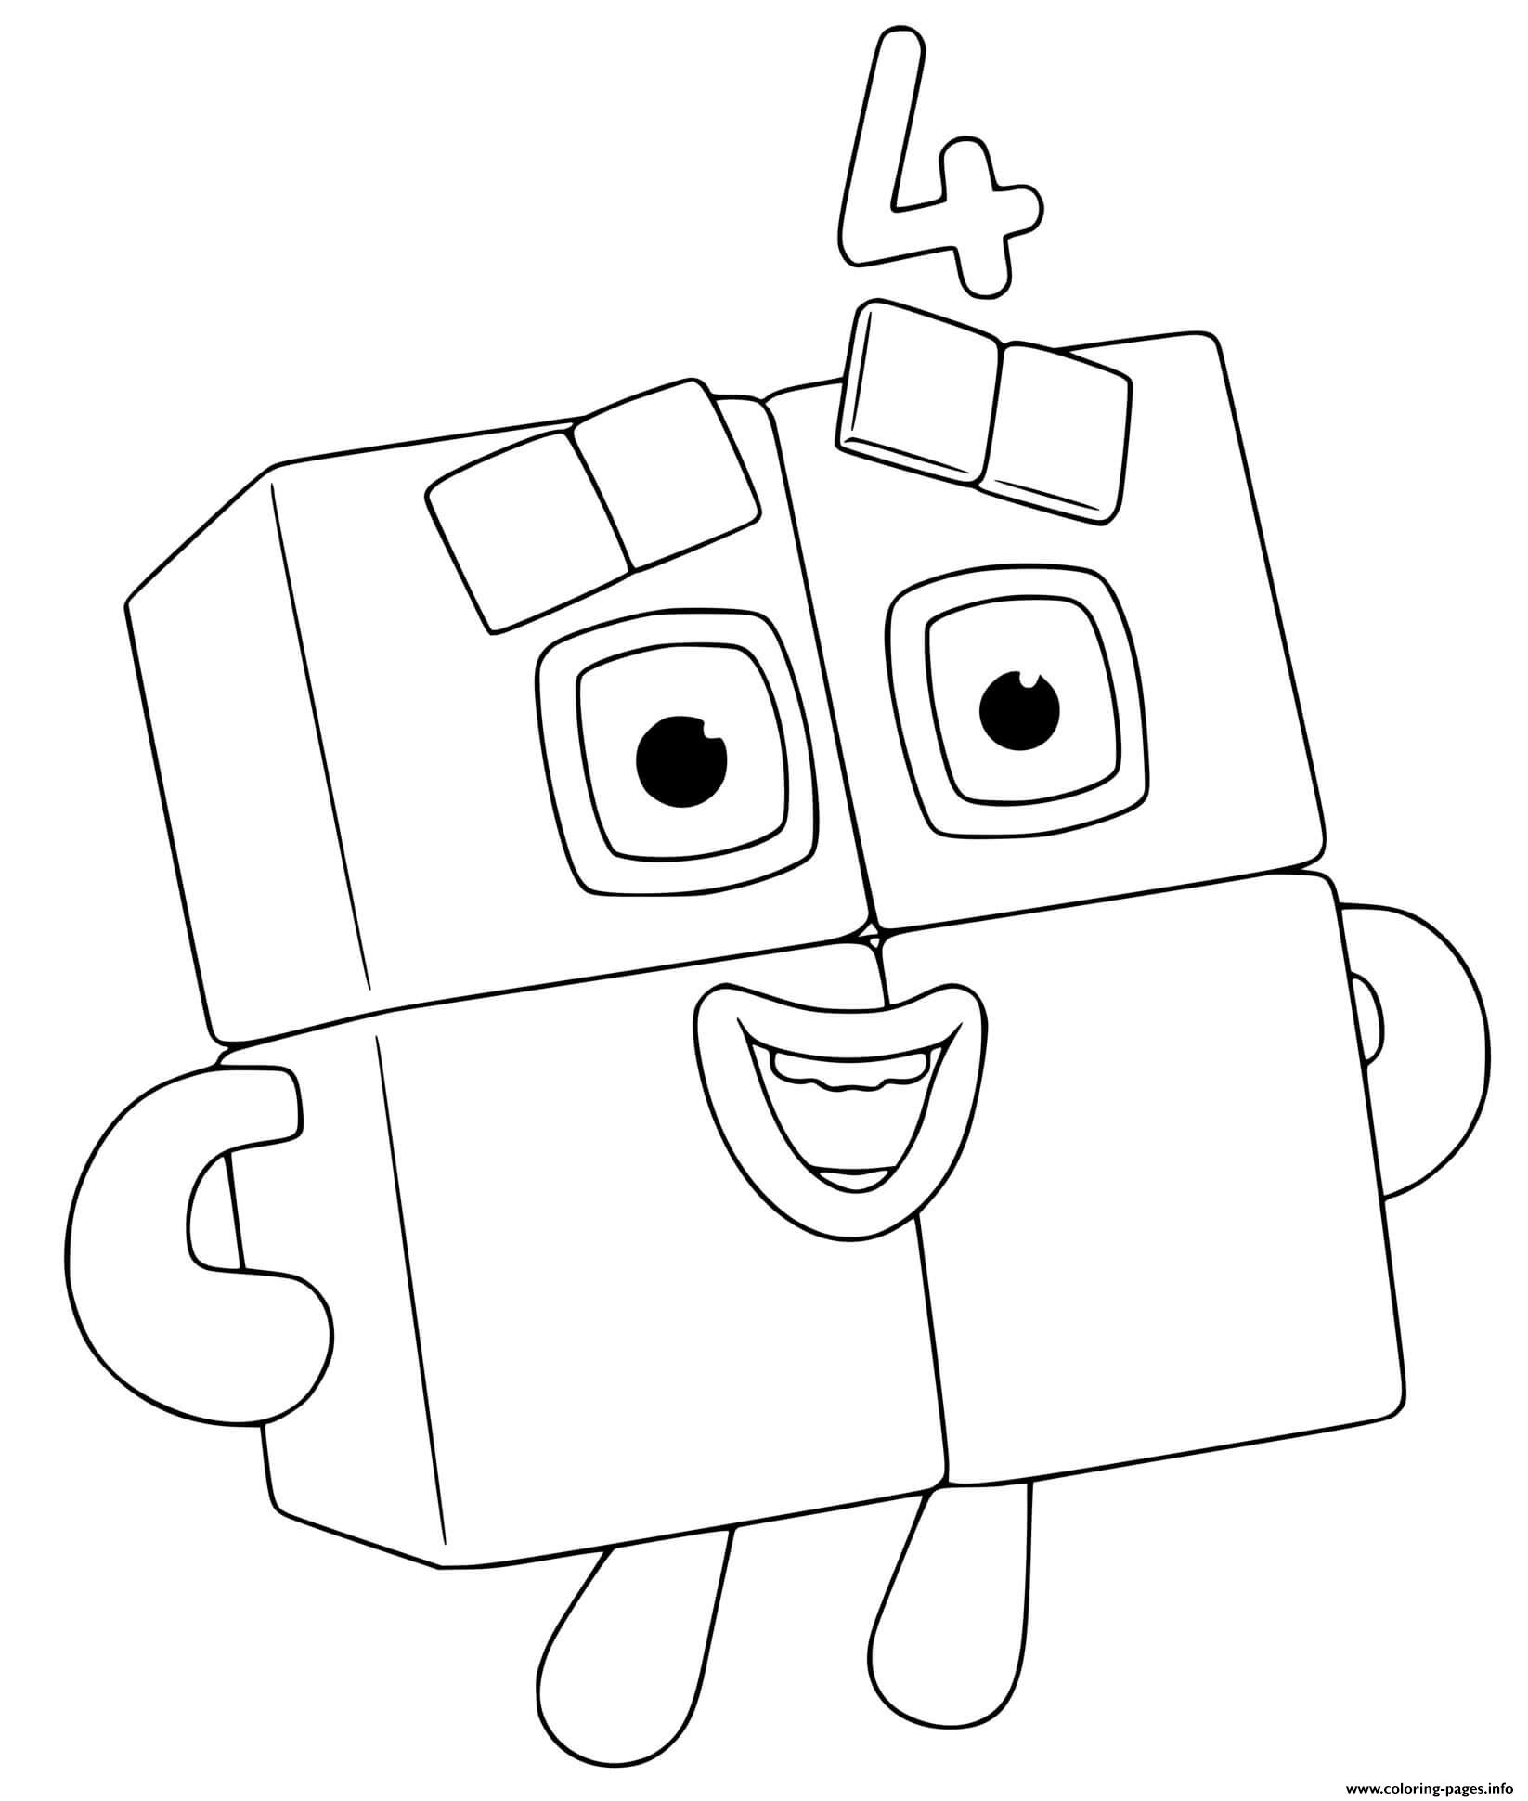

Number 4 – How many things in your house can you collect that have 3 things?

(Eg. 4 finger prints )

**4**

How to make 4 using tens frame and part part whole?

Tens Frame – can you colour in 4 on the tens frame or put 3 objects in to fill the 3 parts of the tens frame?

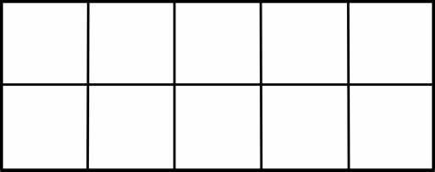

**Part Part Whole**

Can you complete the part part whole? Number 4 has 4 ways of filling in the whole part part.

4 = whole 2 = part 2= part as part + part = whole

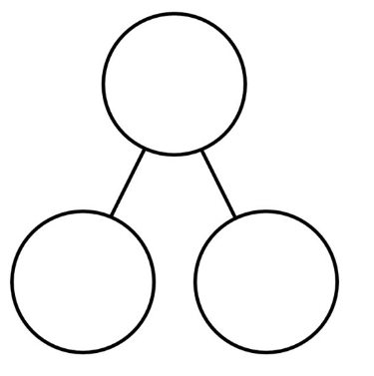

part

whole

part

Using the part part whole can you write a number sentence?



part

2

whole

4

part

2

whole

part

part

=

+

whole

part

part

=

+

<https://www.gamestolearnenglish.com/prepositions-game/>

<https://www.topmarks.co.uk/learning-to-count/ladybird-spots>

<https://www.topmarks.co.uk/early-years/shape-monsters>

Count with Lecky - <http://www.crickweb.co.uk/Early-Years.html>

Match the rhyming words

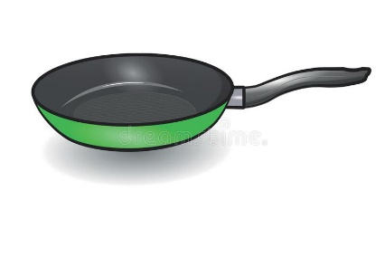

van

man

pan

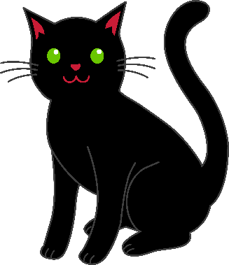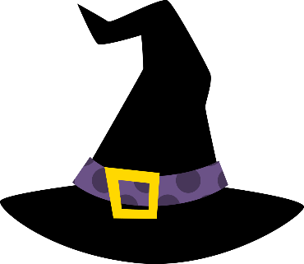Spell Candle Holder - Bat

hat

cat

bat

#

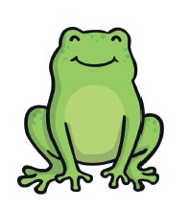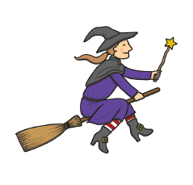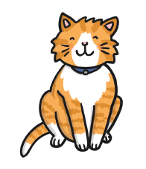

Here are a list of the CVC words the children have been learning to read this half term. We have been encouraging them to ‘sound talk and blend’ the words to read them and helping them to read the word fluently (reading automatically without sound talking and blending).

|  |  |  |
| --- | --- | --- |
| sit | sat | tip |
| nap | pan | man |
| map | mat | dip |
| sad | dig | dog |
| tap | cap | pot |
| cat | got | not |
| kid | kit | sock |
| pick | set | get |
| ten | mum | duck |
| pet | red | run |
| hit | big | hug |
| muck | bat | fat |
| bed | log | hot |

My potion

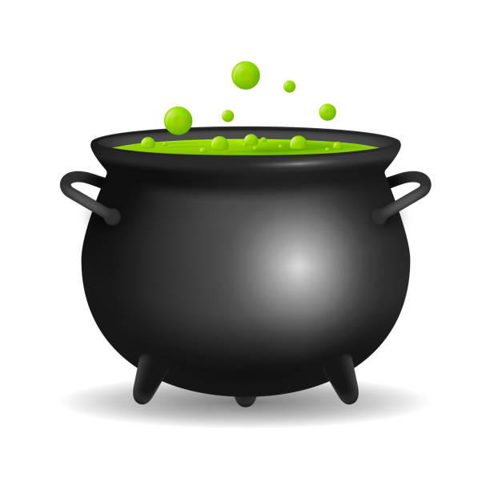

a

t

o

t

a

t