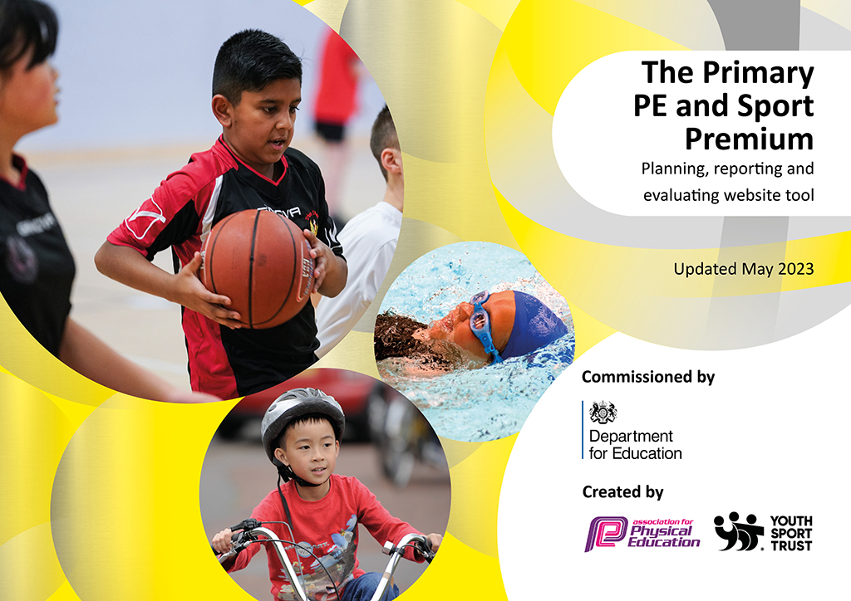
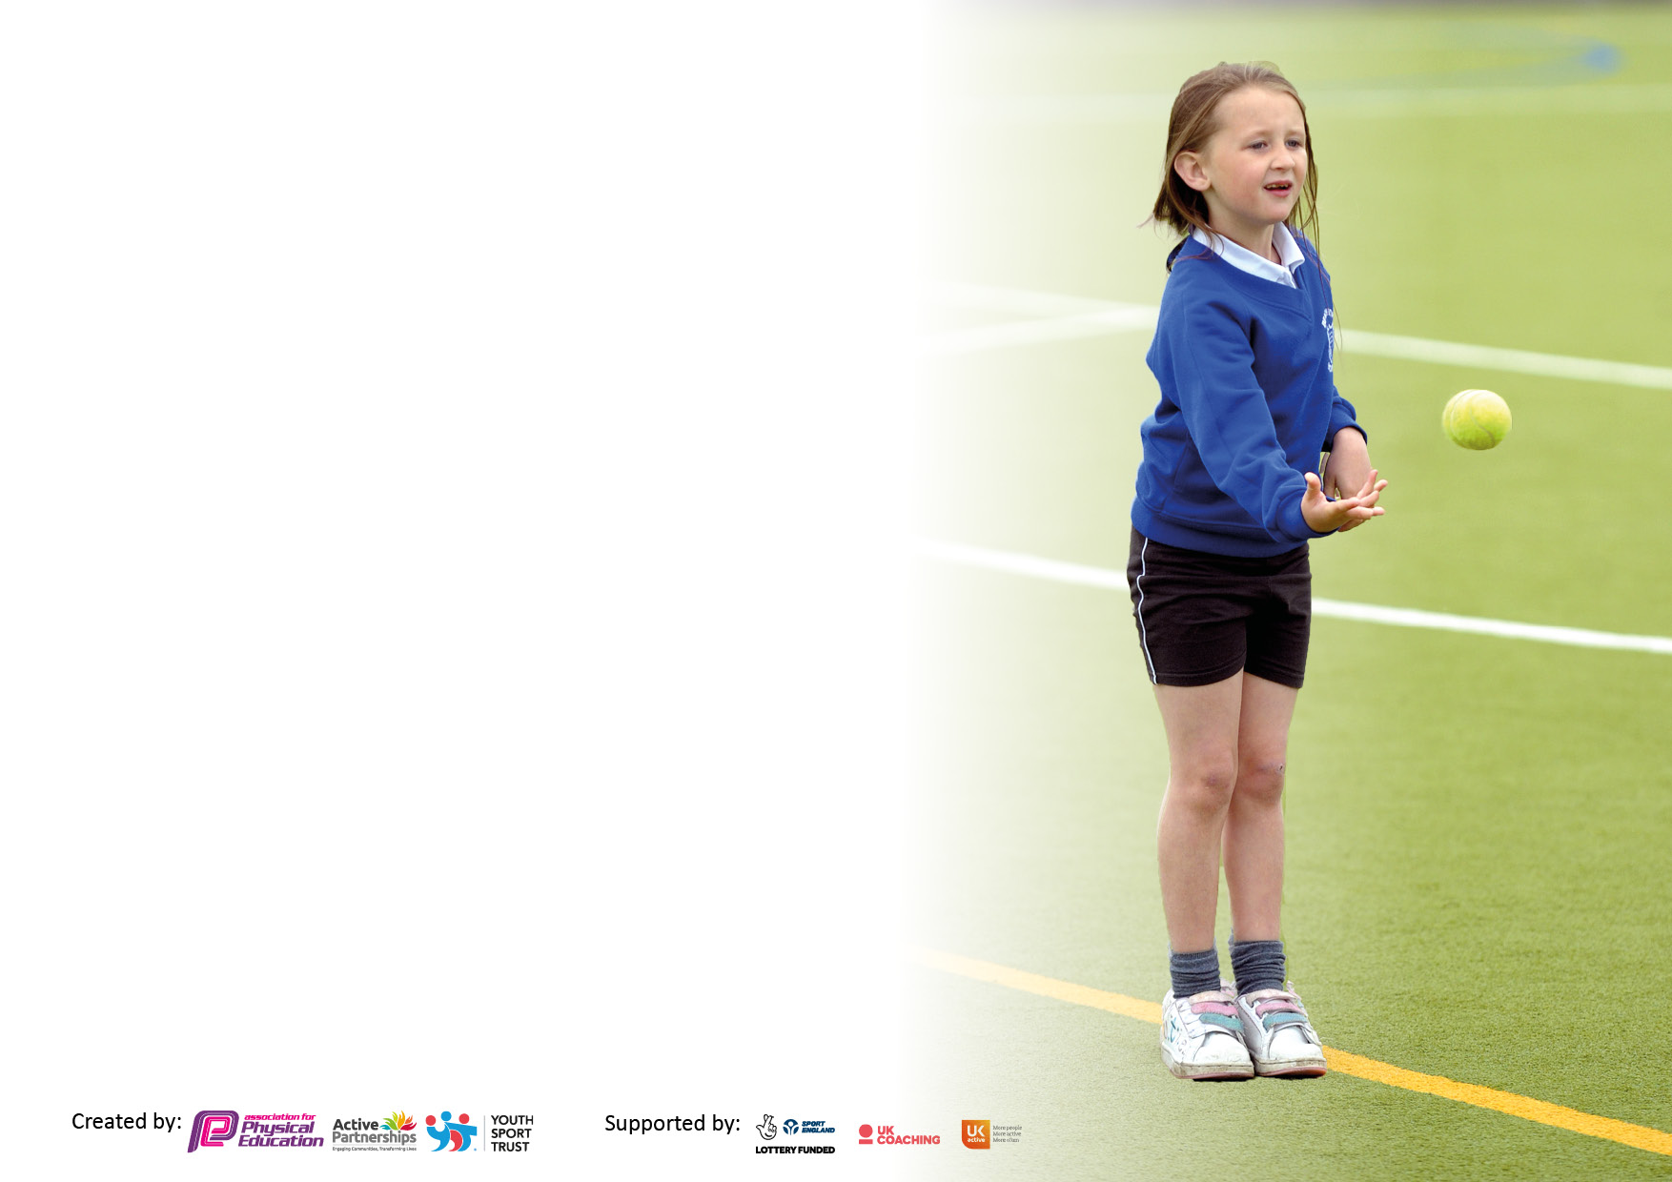

It is important that your grant is used effectively and based on school need. The Education Inspection Framework makes clear there will be a focus on ‘whether leaders and those responsible for governors all understand their respective roles and perform these in a way that enhances the effectiveness of the school’.

Under the Quality of Education Ofsted inspectors consider:
Intent - Curriculum design, coverage and appropriateness
Implementation - Curriculum delivery, Teaching (pedagogy) and Assessment
Impact - Attainment and progress

To assist schools with common transferable language this template has been developed to utilise the same three headings which should make your plans easily transferable between working documents.

Schools must use the funding to make additional and sustainable improvements to the quality of Physical Education, School Sport and Physical Activity (PESSPA) they offer. This means that you should use the Primary PE and sport premium to:

- Develop or add to the PESSPA activities that your school already offer
- Build capacity and capability within the school to ensure that improvements made now will benefit pupils joining the school in future years
- The Primary PE and sport premium should not be used to fund capital spend projects; the school’s budget should fund these.

Please visit gov.uk for the revised DfE guidance including the5keyindicatorsacrosswhichschoolsshoulddemonstrate an improvement. This document will helpyoutoreviewyourprovisionandtoreportyourspend.DfEencouragesschools to use this template as an effective way of meeting the reporting requirements of the Primary PE and Sport Premium.

We recommend you start by reflecting on the impact of current provision and reviewing the previous spend.

Schools are required to publish details of how they spend this funding, including any under-spend from 2021/2022, as well as on the impact it has on pupils’ PE and sport participation and attainment. The funding should be spent by 31st July but the DfE has stated that there will be no clawback of any unspent money so this can be carried forward into 2023/24.

We recommend regularly updating the table and publishing it on your website throughout the year. This evidences your ongoing self-evaluation of how you are using the funding to secure maximum, sustainable impact. Final copy must be posted on your website by the end of the academic year and no later than the 31st July 2023. To see an example of how to complete the table please click HERE.

Hill West Primary School

Total amount carried over from 2021/22 | £00.00
Total amount allocated for 2021/22 | £19,670
How much (if any) do you intend to carry over from this total fund into 2022/23? | £0
Total amount allocated for 2022/23 | £19,670
Total amount of funding for 2022/23. | £19,670

Swimming Data

Meeting national curriculum requirements for swimming and water safety.  Due to exceptional circumstances priority should be given to ensuring that pupils can perform safe self-rescue even if they do not fully meet the first two requirements of the NC programme of study | 100%
What percentage of your current Year 6 cohort swim competently, confidently and proficiently over a distance of at least 25 metres? | 100%
What percentage of your current Year 6 cohort use a range of strokes effectively [for example, front crawl, backstroke and breaststroke]?  Please see note above | 100%
What percentage of your current Year 6 cohort perform safe self-rescue in different water-based situations? | 100%
Schools can choose to use the Primary PE and sport premium to provide additional provision for swimming but this must be for activity over and above the national curriculum requirements. Have you used it in this way? | No

Hill West Action Plan and Budget Tracking 2022-2023

Academic Year: 2022/23 | Total fund allocated: £19,670 | Date Updated: 17.07.23
Key indicator 1: To ensure the engagement of all pupils in regular physical activity – Chief Medical Officers guidelines recommend that primary school pupils undertake at least 30 minutes of physical activity a day in school |  |  |  | Percentage of total allocation:
 |  |  |  | 20%
Intent | Implementation |  | Impact | Next Steps
Actively promote the benefits of a healthy, active lifestyle and purchase equipment to support this through daily physical activity.  To continue to work in partnership with ‘Wilson Stuart Active Society’ to increase awareness of the importance of physical activity | Further encourage use of initiatives such as the ‘Daily Mile’ in ALL year groups at least 3 times a week and encourage children to exercise through play.  Participate in the Active60 survey  through Sport Birmingham and  liaise with them to support our  implementation of PESSPA in  school. | Funding allocated:  Equipment:  £2,460  Wilson Stuart: £1,350  Total: £3,893 | 90% of children are active during recreation times.  99% of pupils surveyed in June 2023 told us that we encourage them to look after their physical and mental health 99% | Monitor physical activity levels to ensure ALL children, including those who are persistently absent, meet the government guidelines of at least 30 minutes a day for each child in school time.  Purchase equipment to enable pupils to be physically active at break times and lunch times.

Key indicator 2: Our children attend a school with a culture that recognizes the value of Physical Education, School Sport and Physical Activity (PESSPA). |  |  |  | Percentage of total allocation:
 |  |  |  | 40%
Intent | Implementation |  | Impact | Next Steps
Weekly non-contact time for the PE lead is guaranteed and is focused on  - improved opportunities and pathways to participate in school sport  - Increasing levels of physical activity throughout the school day.  - Improved physical, social and emotional wellbeing. | Engaging with Sport Birmingham initiative ‘Pathway to Podium’ to audit current provision.  Key Actions  - Increase opportunities for students to lead, manage and officiate  - Administer Active Lives Survey to al pupils in Spring | Funding allocated:  £ 7,800 | Physical Education is led by a subject coordinator who is a qualified teacher and supported to engage with external partners to develop high quality physical education, school sport and to promote physical activity.  Our school provides two hours of high quality timetabled Physical Education per pupil per week led by a qualified teacher  62% of pupils travel actively to school versus 585 nationally.  Pupil’s Wellbeing score was 7.2 / 10 where 0 is low and 10 is high. | Our school has a targeted approach to improving the level of physical activity experienced by all pupils.  Our school has a targeted approach to improving the wellbeing of all pupils.

Key indicator 3: To increase the confidence, knowledge and skills of all staff in teaching PE and sport. |  |  |  | Percentage of total allocation:
 |  |  |  | 12%
Intent | Implementation |  | Impact | Next Steps
Raise the quality of learning and teaching in PE and school sport by providing support to deliver broad, balanced and inclusive high quality PE and school sport provision (within and beyond the curriculum) to raise pupils’ attainment.  To embed a comprehensive scheme of work to support teachers  - To have a deep and fluent knowledge and flexible understanding of the content they are teaching  - Knowledge of the requirements of curriculum sequencing and dependencies in relation t0 the content and ideas they are teaching  - Knowledge of relevant curriculum tasks, assessments and activities, their diagnostic and didactic potential; being able to generate varied explanations and multiple representations / analogies / examples of the ideas they are teaching  - Knowledge of common student strategies, misconceptions and sticking points in relation to the content they are teaching. | To monitor the teaching of PE across school and support staff to teach good or better lessons consistently.  To provide opportunities for staff to access CPLD opportunities through the Sport Partnership CPLD programme.  Use specialist coaches and providers for staff training to increase the knowledge and confidence of staff in delivering PE. | Funding allocated:  £2477 | PE Schemes of work implemented consistently to support children across school in KS1 and KS2.  100% of lessons observed in Summer Term 2023 were good or better.  % of children in each year  group meeting the  expectations in PE at end  2022/2023 was:  - Year 1: 96.7% (58/60)  - Year 2: 95.3% (61/64)  - Year 3: 100% (63/63)  - Year 4: 98.4% (60/61)  - Year 5: 93.9% (61/65)  - Year 6: 93.6% (58/62) | Support ECTs with their teaching of P.E. to ensure their lessons are of a good standard and they are supported to continue to improve.

Key indicator 4: A broader range of school sports and activities offered to all pupils and to increase participation in competitive sport |  |  |  | Percentage of total allocation:
 |  |  |  | 28%
Intent | Implementation |  | Impact | Next Steps
Provide opportunities to take part in a diverse range of school sport through extra-curricular clubs, competitions and events.  Increase participation opportunities for KS1 children  Continue to develop relationships with community coaches so a broad and wide range of activities can be offered to all age groups.  Providing opportunities for children with SEND, the least active and the least confident to attend competitions and events. | Review extra-curricular activities through pupil voice / accreditation  Provide opportunities for children in KS1 and children with SEND across school, to attend exciting, varied and a new range of activities through the school sport partnership e.g Primary Panathlon  Employ sports coaches to provide age and stage appropriate extracurricular sporting opportunities and to improve sports skills in children through increased opportunities in school | Funding allocated:  £5,500 | 10 sports available to participate in PE across school.  Events attended throughout calendar year:  Football (x7), Rugby, Gymnastics (KS1), Tennis, Dodgeball, Sports-Hall Athletics, Cross-Country (x4), Multi-Skills (x2), Panathlon (x2), Ten-Pin Bowling, Area Athletics and Commonwealth Games Legacy Event.  236 total children participating in extra-curricular sport at school (56%) | Carefully select outside providers and ensure they understand our vision for school sport and that the opportunities they offer contribute to that vision.  Further increase opportunities for children to participate in after-school and inter-school events.  Further increase the percentage of children participating in extra-curricular sports through school.  Use of Children’s University to track engagement of children in extra-curricular and competitive sport out of school.

Signed off by
Head Teacher: | Dr Beth Clarke
Date: | 21.07.23
Subject Leader: | Mr Joel Holmes
Date: | 20.07.23
Governor: | Mr Matthew Walker
Date: | 21.07.23

